CHAPTER ONE

INTRODUCTION

1.1 Background to the study
The 21st century has witnessed the emergence of urbanization as one of the pivotal global trends. As a consequence, sustainability, infrastructure, land use and Urban Heat Island has been deeply affected. According to the United Nations (2018), as of 2018, urban areas constituted over 55% of the world’s population. However, with developing regions like Sub-Saharan Africa, the figure has been projected to rise to 68% by 2050. A key contributor to this projected growth is Nigeria, which has cities like Enugu that have been significantly expanding in recent decades. Nnam (2020) conducted a remote sensing and GIS study (spanning 30 years) of a 24,500-hectare urban area. With a notable increase in built-up areas from 15% in 1989 to 45% in 2019, Enugu has evolved into an administrative and commercial center. Based on current trends, this growth was projected to likely exceed 50% by 2024, reflecting Nigeria’s wider evolution to an economy based on services, leading to damaging infrastructure and necessitating advanced planning tools like GIS (Ogbazi, 2013).
According to Addas (2023), local climate anomalies such Urban Heat Island, high-rate conversion of semi-natural and natural landscapes to impervious surfaces, and vegetation loss have resulted to the largely uncontrolled urban development patterns in Nigeria. Urban zones significantly record higher temperatures than rural environments, owing to the occurrence of UHI which happens when urban surfaces (such as asphalt, concrete, and building roofs) absorb and re-emit more heat than natural landscapes. This has negative implications for climate resilience, energy consumption and public health (Adelekan, 2016). As a mid-sized metropolis in southeastern Nigeria, Enugu is experiencing this trend, which is being influenced by real estate development, economic expansion and high rate of urbanization. In urban regeneration programs, the innovative strategies used to minimize the effects of Urban Heat Island include: Remote sensing, Deep Machine Learning (DML) and Geographic Information Systems (GIS). By integrating socioeconomic, climatic, spatial and environmental data, these technologies have the capacity for advanced analysis. (Mutani, G., et.l 2024).
Nnam (2020) conducted a study highlighting the efficacy of GIS. The study revealed that built up areas within Enugu Urban rose from 3,741 hectares in 1989 to 11,055 hectares in 2019. With all socioeconomic factors remaining constant, this has been projected to rise to 15,119 hectares in 2029. From the global perspective, Dewan and Yamaguchi (2009) conducted a related study using GIS to monitor 10 years of land use change in Dhaka. Their findings also showed the impact of urban sprawl on land resources.
According to Zhou et al. (2019), urban geospatial analysis has been transformed by advancement in technology like Machine Learning. Particularly in the aspect of deep learning, Machine Learning has introduced greater accuracy in pattern recognition, temporal modeling and automated feature detection.
In extracting spatial features from high-resolution imagery with the use of deep learning models, certain models like Conventional Neural Networks (CNNs) are particularly effective. Albert, Gonzalez and Kaur (2017), conducted a study with CNNs trained to detect urban land features at scale using satellite images. This showed a highly layered and detailed urban morphological structures. According to Boulila et al., (2021), temperature variation overtime and urban expansion can be forecasted when CNNs are integrated with recurrent neural networks such as LSTM. The learning of spatial temporal patterns is permissible with these hybrid models, which enables the prediction of not only where UHI intensifies but of when UHI are likely to get intensified.
Recent studies prove that traditional LULC classification techniques are outperformed by deep learning models. Using a deep neural network regressor with multisource satellite data, over 92% accuracy was achieved by Hoang and Nguyen (2025) in predicting UHI intensity in Southeast Asian cities. In a similar vein, while applying CNNs to identify LULC change in Lagos, Nigeria, Ahmed et al. (2024) noted significant correlation between urban sprawl and LST elevation. A more precise insight to thermal stress zones was provide in their models, which is crucial for planning cities that are resilient to climate.
By providing tools to predict future growth and analyze spatial patterns, the application of Remote Sensing and Geographic Information Systems (GIS) has radically changed urban planning. In a manual for the new generation of British planners, created by the 1947 Town and Country Planning Act, Lewis Keeble (1952) explained that: “There are two ways in which interrelated survey subjects can be compared: the first is by means of overlays, the second by means of combination or sieve maps” which suggest “practical ways to analyze and sort land by combining information (overlays) or ruling out bad options step-by-step (sieve maps), making it easier for planners to pick the right spots for development.”
(Keeble 1952, p. 70).
The above statement from Lewis Keeble is implemented through the use of GIS. This is because GIS assists planners in integrating a wide range of datasets including infrastructure maps, population statistics, satellite imagery, and climatic data, to inform policy and understand urban dynamics (Batty, 2008).
The efficacy of GIS and Remote Sensing in tracking land use changes in more than a decade in Dhaka, Bangladesh, was demonstrated by Dewan and Yamaguchi (2009). The study showed how urban sprawl can strain resources if left unchecked. Looking at the period between 2000 - 2024 give us the opportunity to assess how development has unfolded and the correlation with Urban Heat Island, also to predict future trends in Enugu Urban. During this period, Enugu has witnessed population growth, infrastructural expansion, and increased commercial activity, yet much of this development has occurred without comprehensive planning, leading to challenges like traffic congestion and environmental degradation. Enugu’s urban evolution is particularly significant given its strategic role as the capital of Enugu State and a gateway to southeastern Nigeria. Between 2000 and 2024, the metropolis has expanded beyond its colonial-era boundaries, driven by factors such as improved road networks and the rise of informal settlements (Ezeh & Ugwu, 2019). However, the lack of systematic data on these changes has hindered effective urban management. GIS offers a solution by enabling spatial analysis of historical growth and predictive modeling for future scenarios. Alsharif and Pradhan (2014) exemplified this in their study by using GIS to map urban sprawl in Tripoli, within a similar timeframe. This study leverages Deep Machine Learning and GIS to examine Enugu’s urban development and urban heat island patterns over the past decade, to make growth forecast to 2045, addressing a critical gap in local planning knowledge. By doing so, it aims to contribute to sustainable urban development strategies tailored to Enugu Metropolis and potentially applicable to other Nigerian cities facing similar pressures.

1.2 Statement of problem
Looking at Enugu development pattern, from 2000 to 2024, it has experienced unparalleled changes in urban development, marked by significant land use transformations and a gradual drift toward urban fragility. These shifts have led to increase in Urban Heat Island effects (UHI), enormous challenges in infrastructure provision and an increasing struggle to meet the rising demands of a growing population. Rapid population growth, coupled with migration, industrialization, and the decentralization of economic activities, has fueled unplanned and uncontrolled urban expansion, distorted original master plans and exacerbating environmental degradation. The loss of agricultural lands, fragmentation of natural ecosystems, and continuous decline in environmental quality threaten both human well-being and the natural environment, as noted in broader urban studies (He et al., 2018). Conventional remote sensing studies has effectively map past changes but lack predictive frameworks that integrate deep learning. As Enugu urban areas expand into peri-urban zones, planners require accurate AI-driven tools to anticipate thermal stress hotspots and guide sustainable development. (Ofordu et al., 2022) Meanwhile, urban planners in Enugu face a daunting task, compounded by the need to transition from a centrally planned system to one adaptable to a modern, transitional economy. This challenge is further intensified by political interference, compromises by public servants, and inadequate funding, which collectively undermine effective urban management. Without a robust, data-driven approach like Geographic Information Systems (GIS), Remote sensing data and application of Deep Learning (DL) to analyze these patterns and predict future trends, Enugu risks deepening its infrastructure deficits and environmental losses, making sustainable urban development increasingly elusive.

1.3 Research Objectives
Aim
To apply deep machine learning (CNN-based architectures) in analyzing and predicting urban development and UHI patterns in Enugu from 2000 to 2024 and predict future growth trends up to 2045, for sustainable urban planning and management.

The specific Objectives are:
- To analyze urban development and urban heat island patterns in Enugu Metropolis from 2000 to 2024 using GIS.
- To apply a CNN-driven model for high-resolution LULC and UHI mapping.
- To Predict future urban expansion and UHI hotspots up to 2045.
- Evaluate the deep learning approach’s accuracy, comparing it to conventional methods.

1.4 Research Questions
- What are the patterns of urban development and urban heat island (UHI) changes in Enugu Metropolis between 2000 and 2024?
- How effective is a CNN-driven model in generating high-resolution land use/land cover (LULC) and UHI maps for Enugu Metropolis?
- What are the predicted patterns of urban expansion and UHI hotspots in Enugu up to the year 2045?
- How does deep learning approach compare with conventional remote sensing and GIS methods for analyzing urban development and UHI patterns?

1.5 significance of the study
This study is stand out and tend to contribute to the body of knowledge in area of using Deep machine learning, Geographic Information Systems (GIS) and Remote sensing to analyze and predict urban development and urban heat island (UHI) patterns in Enugu as there are few or non research work in this aspect within the study area. Despite Enugu’s rapid transformation from 2000 to 2024, driven by population growth and economic shifts, there has been limited systematic analysis of its urban development and urban heat island patterns or predictive modeling to guide future growth. This study fills this void by employing Deep Machine Learing, GIS and Remote Sensing to map a decade of change and forecast trends to 2045, offering a detailed, data-driven understanding of the metropolis’s urban dynamics. By doing so, it not only contributes to the academic discourse on Nigerian urban studies but also establishes a foundation for further investigations into similarly under-researched cities in the region. Beyond its academic value, this research serves as a practical blueprint for urban planners and policymakers in Enugu Metropolis and similar transitional urban centers. The GIS-based and application of Deep Machine Learning insights and predictive models developed here provide an actionable toolset for tackling pressing challenges, such as uncontrolled sprawl, infrastructure deficits, and environmental degradation. Planners can use this study’s findings to adapt Enugu’s outdated, centrally planned system to the demands of a modern, market-driven economy, aligning land use with sustainable development goals. Moreover, the methodology and recommendations offer a replicable framework that can inform planning strategies across Nigeria, where many cities grapple with comparable issues of rapid, unplanned urbanization. Lastly, it offers evidence-base results to address uncontrolled urban growth, infrastructure strain, and environmental challenges from 2000 to 2024, enabling the State Government to plan sustainably for 2045. By filling the research gap and serving as a blueprint, it equips local and state authorities with data-driven insights to update outdated planning systems, optimize budgets, and enhance urban resilience, climate resilience, ultimately improving governance and public welfare. Thus, this study holds both local relevance for Enugu and broader significance as a model for enhancing urban resilience and sustainability.

1.6 Study Area
Enugu State is one of the states in the south-eastern part of Nigeria. It shares borders to the south with Abia State and Imo State, to the east with Ebonyi State, to the northeast with Benue State, to the northwest with Kogi State and to the west with Anambra. Enugu is the capital city of Enugu State which lies between latitude 060 210 N and 060 300 N and between longitude 070 260 E and 070 370 E. It is bounded in the East by Nkanu East Local Government Area, in the West by Udi Local Government Area, in the North by Enugu East Local Government Area and in the South by Nkanu West Local Government Area (see figure 1).
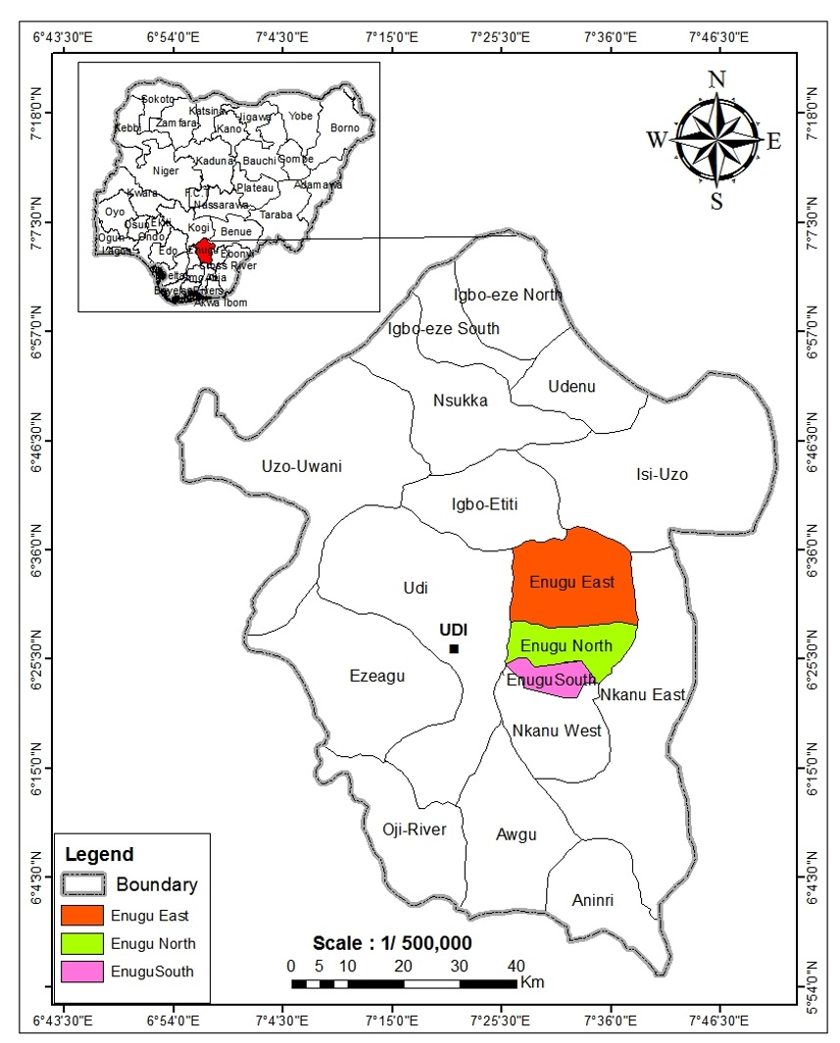
Figure 1: Map of Enugu Showing the Study Area
Enugu Metropolis, the capital of Enugu State in southeastern Nigeria, spans three Local Government Areas: Enugu East, Enugu South, and Enugu North (see Figure 1). Predominantly populated by the Igbo ethnic group, this medium-sized urban center has undergone rapid growth, particularly from 2000 to 2024, with notable increases in built-up areas, immigration, transportation infrastructure, and commercial activities (Okeke et al., 2019). Covering 556 km² (215 square miles), Enugu ranks as Nigeria’s 9th most populous city per the 2006 National Population Census, with a population density of 1,300/km² (3,400/sq mi). This study targets the metropolis’s urban development between the decade of 2000-2024, capturing its transition from a coal based legacy to a thriving commercial and administrative hub, making it a compelling case for GIS-based analysis. Enugu’s demographic expansion highlights its dynamic evolution and the pressures driving this research. Historical census data show a steady rise: the population was 62,764 in 1952, climbed to 462,514 by 1991, and reached 722,664 by 2006, housed within its residential layouts (NPC, 1991, 2006). The projected population grew to 1,064,983 by 2018, with Abakpa as the most densely populated neighborhood and Maryland the least (Okeke et al., 2019). Extending this trend, the population of Enugu Metropolis is estimated to have reached approximately 1.2 million by 2024, based on an average annual growth rate of 2.5% from 2006 onward, reflecting ongoing migration and economic pull factors. This escalating growth has intensified land use changes and infrastructure demands, positioning Enugu as an ideal study area for mapping past patterns and predicting future urban trajectories using GIS.

CHAPTER TWO

LITERATURE REVIEW
In studying the existing theories on spatial structure of cities, the theoretical framework ushers in the literature review. The linkage between uncontrolled development patterns and socio-economic activities is examined through the Urban sprawl theory. With the postulation that urban development radiates from a busy central hub (the core) to less developed outer zones (the periphery), the core-periphery growth model serves as another relevant framework. The rent theories school of thought (also known as bid‐rent theory) suffices as another set of theories. The Bid rent theory’s concept states that a trade‐off between transportation costs and rents is reflected in the urban structure. In addition to these theories, the social ecology theory entails axial theory, Sector theory, concentric zone theory, and multiple‐nuclei theory.

Theoretical Framework

2.1 Urban Development Patterns Theories

Urban sprawl Theory
Urban sprawl theory describes uncontrolled and unplanned development in urban centers in the face of increasing population. Shaped by social, environmental and economic forces, urban development patterns reflect the temporal and spatial evolution of cities, which is crucial to understanding growth over a decade-long period (such as the case of Enugu Metropolis between 2000 and 2024). Urban sprawl is one foundational theory that is often driven by infrastructure development and population growth, and characterized by low-density and unplanned expansion beyond a city’s core. According to Galster et al., (2001), sprawl is a phenomenon increasingly noticeable in rapidly urbanizing regions like Sub-Saharan Africa. It is a pattern of land use that is characterized by automobile dependency, scattered development and inefficient resource use (Galster et al., 2001). Within the study period in the context of Enugu, sprawl is fueled by economic shifts and migration, and may manifest as commercial and residential zones extending into peripheral areas like Gameze, Abakpa and Obiagu. Since this theory captures gradual but cumulative changes in land use that GIS can quantify through spatial mapping and satellite imagery, it is particularly relevant for a decade-long analysis.

Core periphery growth model
Another relevant framework is the Core periphery model. It theorizes that urban development radiates towards the less developed outer zones (the periphery) from the dense central hub (the core), often following infrastructure corridors and economic gradients. This concept was introduced by Friedmann (1966) to explain uneven development; in which resources are concentrated in the core such as Enugu North’s administrative and historical center, while secondary growth is experienced in peripheral areas like Enugu South and East (Friedmann, 1966). For more than a decade a predictable outward expansion has been suggested using this model, with commercial hubs and transportation networks acting as catalysts. Batty (2008) complements this by noting that urban growth often follows predictable spatial patterns that are measurable with GIS. They include: fractal or radial configurations that emerge as cities decentralize and densify (Batty, 2008). In the case of Enugu, GIS can track and detect land use changes from 2000 to 2024. This could mean tracing how the core’s influence declines as peripheral neighborhoods grow.

Concentric Zone Theory
This theory was postulated by Burgess in 1925. Under the Concentric Zone Theory, the physical expansion of the city is linked to societal organization and population growth. Burgess used the theory in identifying factors responsible for Urban growth and to determine a pattern for the social structure of the city (Scargill, 1979). To analyze spatial organization of land use in Urban area and its change over time, the theory serves as a descriptive framework. Some economic factors partially formed the basis of the Theory. Many assumptions were made by the model including: accessibility to a single centered city, uniform land surface, free market, a commercial industrial base, and heterogeneous population (Herbert and Thomas, 1990). Burgess concluded that the city was made up of concentric zones with the central business district (CBD), as a result of his research on the distributional pattern of various groups of society. All major political, commercial, and social activities were found within the core of the CBD. This was surrounded by a transition zone, which had slums and factories. Older residential districts were found in this zone, but they were being taken over by the expanding CBD. Lower income housing was found in the next zone, with successive zones having higher income residences (Burgess, 1929). When their zone was invaded, families moved out into the next zone. The premise of this model was based on invasion and succession, such that as the economic and social status of population group improves, they gradually move out. The main cause of the social pattern was attributed to mobility and migrant influx (Hartshorn, 1992). Burgess’ experience in mid-western American cities, especially Chicago formed the basis for the model. Most American cities in the mid-west absorbed many immigrant groups from Europe, in the early 1920s. These immigrants first found cheap housing in the inner city, but with affluence they moved to better housing districts— towards the periphery (Burgess, 1929). Diversification in employment opportunities ushered in the growth of mixed land use development, which forced an outward expansion. Significant improvements in public transport system enabled the middle-class to travel from outer zones to the CBD for work. These reasons complemented a concentric zone development model (Scargill, 1979). Due to the model’s simplicity, it can be used to predict how urban land markets work. According to King and Golledge, (1978), it was intended to serve as a framework for studying urban change and growth. However, Burgess has been criticized for not having considered topographical criteria. According to Scargill (1979), specialized clusters of industry were not taken into account in the original model. The impact of transport networks on these zones was also not explained.
Particularly in medium-sized cities like Enugu undergoing rapid transformation, theories of core-periphery growth and urban sprawl are not mutually exclusive but often interplay. Brueckner (2000) argues that market failures such as land pricing or inadequate planning that leads to uncontrolled peripheral expansion are what leads to sprawl. In transitional economies where centralized systems weaken, this scenario is made worse (Brueckner, 2000). In the case of Enugu, the shift to a commercial based economy from a coal-based one between 2000 and 2024 may have fast tracked this dual pattern, with the core retaining administrative functions while the periphery absorbs informal and residential economic growth. Ewing et al. (2016) further highlights how the occurrence of sprawl in over a decade can strain infrastructure and fragment natural ecosystems. Such outcomes can be mapped with GIS to reveal the fragility of Enugu urban.
By emphasizing gradual, observable shifts rather than abrupt changes, these theories provide a lens for a decade-long study. For instance, the concentric zone model by Burgess (1925), while foundational, assumes a slower, historical progression less suited to Enugu’s rapid 21st-century growth, whereas sprawl and core-periphery dynamics align with its recent trajectory. Batty’s (2008) assertion that GIS can measure these spatial patterns is crucial here, as tools like change detection and overlay analysis can quantify sprawl’s extent or the periphery’s growth rate in Enugu (between 2000 to 2024). Moreover, Make et al. (1995) propose that urban growth exhibits irregular self-similar patterns and fractal properties. This offers a mathematical basis for GIS to predict future expansion, like Enugu’s potential sprawl by 2045. This predictive capacity is vital for a city evolving to a modern economy— where planning must adapt to dynamic urban forms.

2.2 Urban Heat Island (UHI)
The temperature at the city's center in most urban areas is usually higher than the suburban area or its surroundings. Muktar, Aremu, & Daful (2025) refer to this as the Urban Heat Island (UHI) effects. The elevated temperatures in urban environments compared to surrounding rural areas is referred to as The Urban Heat Island (UHI) phenomenon. It is driven by the dense presence of impervious surfaces like rooftops, concrete, and asphalt, which absorb and retain heat more than natural terrains (EPA, 2009; Wikipedia, 2025). Significantly lower albedos and higher heat capacities are present in Urban materials. This causes cities to heat up during the day and remain warm into the night, often trapping heat under inversion layers (Wikipedia, 2025). This microclimatic alteration has profound implications for energy demand, urban ecology and human health. For example, in rapidly developing cities such as Chicago, Concepción and Delhi, during the day urban surfaces commonly exhibit temperature differences of 1-3 °C, but at night it rises up to 5 °C. (Wikipedia, 2025; Reddit, 2023). A temperature difference which often develops between cities and their surrounding suburbs causes discomfort to city dwellers.
By revealing a strong spatial correlation between land surface temperature (LST) and built-up density, remote sensing and GIS studies have quantified UHI intensity In Nigeria. A notable case study in Kosofe, Lagos, showed that during dry seasons LST peaks of 28-38 °C. Built-up density was identified as a primary driver of local temperature increases, with urban centers consistently hotter than vegetated zones (Ofia et al., 2024). Similarly, a UHI assessment in Jos observed substantial expansions of UHI influence from the central business district to peripheral neighborhoods over a 32-year period, showing the dominance of bare-surface and impervious land covers (Akinseye & Zitta, 2020). These findings correlate with global UHI studies that have consistently demonstrated the heat-buffering effect of vegetation, in which compared to surrounding built environments, local temperature in green areas are reduced by approximately 2 5 °C (Silva et al., 2018; Wikipedia, 2025).
To explain UHI dynamics, vegetation metrics such as the Normalized Difference Built-up Index (NDBI) and NDVI are frequently used. A study of Prayagraj, India, revealed that while SUHI varied between 0.4 and 4 °C depending on seasonality, forested areas were 2.25-4.8 °C cooler than built-up areas (Sarif, Gupta, & Murayama, 2023). In the same vein, Bala et al. (2021) found that UHI strength in Varanasi was positively correlated with impervious surface coverage and negatively correlated with vegetation cover. These results affirm the conclusion of Land et al. (2008) that UHI is driven by both landscape fragmentation and land-use configuration. According to Frontiers, (2021), UHI intensity often peaks at suburban zones and urban fringes, where the ratio of green cover to impervious surfaces changes substantially over time.
UHI alters atmospheric conditions and not only affect surface temperature. It causes increased wind patterns, intensified thermal convection, nocturnal temperatures, cloud formation, and shifts in precipitation (Sprinkler et al., 2024; Wikipedia, 2025). In Instabul for example, while nocturnal UHI increased at 0.41 0.50 °C per decade, the daytime UHI has risen by approximately 0.18 °C per decade. This is largely driven by decreased cloud cover and daytime evapotranspiration (Ünal et al., 2020). According to Kong et al., (2023), surface energy budget analyses show that urban areas store up to 200 W/m² more heat than rural vegetation during heatwaves, leading to prolonged heat stress and higher night-time temperatures in cities like Sydney, Australia.

2.2 Urban Ecology Theory
Urban ecology studies the complex interactions between human populations and their built and natural environments within cities. Urban ecology is the study of the relationships of nonhuman organisms and humans in urban areas, the interactions of these organisms with the built and native physical environment, and the effects of these relationships on the fluxes of energy, materials, and information between nonurban and urban systems and within individual urban systems. Cities are viewed not only as built environments but also as ecosystems characterized by biodiversity patterns, energy flow, and fragmentation (Trepl, 1995; Kennedy, Cuddihy, & Engel-Yan, 2007). Urban ecology applies the concepts and methods of the biological science of ecology to urban areas, but to produce a hybrid discipline, it requires and integrates with the concepts, approaches and concerns of social sciences. Urban ecological systems include infrastructure and buildings, as well as landscapes, populations, individual organisms, and communities. (Pickett, S.T.A., Cadenasso, M.L., 2012). Ecosystem patchiness is one central concept. Within a concrete sea, urban green areas act as biological islands, influencing heat species diversity and distribution (Trepl, 1995; MacArthur & Wilson, 1967). This sort of fragmentation increases the Urban Heat Island (UHI) effect, because impervious surfaces absorb heat while isolated vegetation patches fail to mitigate it (Ellis & Ramankutty, 2008; Trepl, 1995).
Among ecological processes, physical infrastructure, and human activity, this theory emphasizes feedback loops. For example, evapotranspiration is reduced by limited green cover, which contributes to elevated temperatures, consequently influencing urban decisions and public perception to remove or plant vegetation (Grimm et al., 2008; Zhao et al., 2022). To capture hidden socio ecological processes such as perception shifts and policy decisions, these interactions are often modeled through mechanistic, Bayesian network, and state-space approaches (Zhao et al., 2022). With regards to UHI, Urban Ecology Theory supports the design of mitigation interventions such as rooftop gardens and green belts, that target both ecological functions and spatial heterogeneity to reduce urban thermal stress (Zhao et al., 2022).

2.3 GIS in Urban Planning
Geographic Information Systems (GIS) offers robust tools to map, analyze, and predict land use changes, making it essential in urban planning, especially rapidly urbanizing regions like Enugu Metropolis in Nigeria. GIS enables planners to visualize and interpret urban dynamics with high precision by integrating diverse spatial datasets satellite imagery, infrastructure maps, and demographic statistics into a unified framework. Longley et al. (2005) emphasize the ability of GIS to overlay multiple data layers, revealing interconnections among economic, social, and physical factors that fuel the growth of the city over time. This capability is essential for medium-term studies like this one, where Enugu’s urban evolution demands detailed insights into patterns spanning 2000 to 2024. GIS is positioned as an essential tool for addressing the challenges of rapid urbanization due to its dual role in predictive modeling and historical analysis.
In urban planning, an essential application of GIS is a decade long tracking of land cover and land use changes, a method directly relevant to Enugu’s 24-year trajectory. Gadiga and Galtima (2017) applied GIS to monitor Gombe Metropolis from 1984 to 2015. Landsat imagery was classified with the Maximum Likelihood algorithm, driven by its 1996 state capital status, a 133% increase in built-up areas (2,385.27 hectares) was seen between 1991 to 2003, followed by a 61% rise (2,582.02 hectares) by 2015. In a similar study covering Enugu Urban, Nnam (n.d.) applied remote sensing and GIS in documenting built-up areas rising from 4,100 hectares in 1999 to 11,055 hectares by 2019 within a 24,500-hectare area. This showed a relatively tripled increase, likely exceeding 50% by 2024 (Nnam, n.d.). These Nigerian cases reflect global examples, such as the study done by Dewan and Yamaguchi (2009) identifying sprawl’s encroachment on natural landscapes and tracking two decades of land use change in Dhaka. In the case of Enugu, GIS can map the shift from 2000 near Nnam’s 1999 baseline to 2024, capturing the expansion fueled by a population increase from 722,664 in 2006 to an estimated 1.2 million (NPC, 2006).
With the ability to enable forecasts like the decade beyond 2024 in Enugu, the predictive power of GIS further enhances its utility for urban planning. Gadiga and Galtima (2017) employed Markov Chain analysis within IDRISI’s Land Change Modeler and Multi-Layer Perception (MLP) neural networks to predict Gombe’s growth. Bulit-up areas were projected to rise to 16,138.3 hectares by 2055 from 6,759.72 hectares in 2015, though at a declining rate due to static assumptions (Gadiga & Galtima, 2017). In contrast, to simulate a decade of growth in San Francisco, Clarke and Gaydos (1998) utilized Cellular Automata (CA) in the SLEUTH model, integrating variables like land availability and transportation. Nnam (2020) adopted regression analysis for Enugu, offering a simpler yet effective approach, in predicting 15,119 hectares by 2029. Leveraging 2000-2024 trends to anticipate infrastructure needs and future sprawl, these methods (regression, MLP, and CA) provide a toolkit for this study to forecast Enugu’s growth to 2045.
Beyond prediction and mapping, GIS assesses the impacts of urbanization on ecosystems and infrastructure, which has been a pressing concern for Enugu within the period of 2000-2024. Poelmans and Van Rompaey (2010) combined GIS with hydrological models in Flanders. This linked sprawl to increased flood risks, a scenario relevant to the declining forests in Enugu (39.12% to 12.90% by 2019 per Nnam) (Poelmans & Van Rompaey, 2010; Nnam, n.d.). Similarly, Gadiga and Galtima (2017) noted Gombe’s vegetation loss (11,248.1 hectares in 1984 to 1,696.14 hectares in 2015), leading to worsened soil erosion and runoff, alongside socioeconomic issues like slum growth (Gadiga & Galtima, 2017). In Enugu, where farmlands dropped from 41.47% to 19.55% by 2019, GIS can fish out pressure points such as the congestion in Abakpa, which can inform targeted interventions (Nnam, 2020). In linking over a decade of growth to transportation, Cheng and Masser (2003) further demonstrates GIS’s role in Wuhan, a method applicable to Enugu’s expanding road networks.
GIS’s adaptability to developing contexts where informal growth and data scarcity prevail, is particularly relevant to Enugu and Nigeria. Oloukoi et al. (2014) used GIS in Porto-Novo, Benin, to map over a decade of informal settlements despite limited records, a challenge reflected in Enugu’s transitional economy. Gadiga and Galtima (2017) relied on freely available Landsat data, processed with ArcGIS and IDRISI, with Nnam (n.d.) similarly utilizing Landsat imagery, both offering a practical approach for Enugu. Aligning with this research’s aim to update Enugu’s land use data beyond 2019, these studies highlight GIS’s capacity to deliver insights in resource-constrained settings. This study can refine its methodology as well as adapt CA or MLP to predict Enugu’s 2045 landscape based on 2000-2024 patterns, by integrating Gadiga and Galtima’s Gombe analysis with Nnam’s Enugu findings.

2.4 Remote Sensing of Land Surface Temperature (LST)
Satellite‐based estimation of Land Surface Temperature (LST) is fundamental for assessing environmental dynamics and urban thermal patterns. LST is essential for understanding surface-atmosphere energy exchange processes because it represents the radiative "skin" temperature of the Earth's surface and (Jaber & Abu-Allaban, 2020). With the employment of pixel‐based retrieval methods such as the split‐window, single channel, and temperature emissivity separation (TES) algorithms, the earliest efforts utilized thermal infrared (TIR) sensors on satellites like Landsat, MODIS, and AVHRR to translate radiance measurements into surface temperature (Jiménez‐Muñoz & Sobrino, 2003; Hulley & Hook, 2011; Wang et al., 2018).
To correct atmospheric effects, the split‐window method leverages on two adjacent thermal bands. Owing to its balanced accuracy and applicability to sensors like MODIS and Landsat 8 TIRS, it has achieved widespread adoption (Becker, 1987; Jiménez‐Muñoz et al., 2009; Wang et al., 2018). For example, Jiménez-Muñoz et al. (2014) integrated thermal emissivity retrievals to support LST estimation, improving accuracy across mixed land covers. Ground validation studies reveal that when properly calibrated, these methods typically yield mean absolute errors under 1 K (Wu et al., 2019).
Even so, satellite LST products continue to struggle with two inherent tradeoffs: spatial vs. cloud cover gaps and temporal resolution. While geostationary sensors provide temporal richness at coarser spatial scales (1-5 km)– scanning resolution references, polar‐orbiting platforms like Landsat offer fine spatial detail (10-30 m) but limited revisit frequency.
Through spatio-temporal fusion techniques combining data from different orbital platforms with land surface models, recent advancements address these constraints to produce gapless, high resolution LST grids. For example, Ma et al. (2021) demonstrated a fusion model combining climate simulations, MODIS and Landsat to create 60 m, 30-minute interval LST products, achieving ±1 K validation accuracy.
The birth of deep learning, particularly Convolutional Neural Networks (CNNs), has further transformed enhancement workflows and LST retrieval. Nguyen et al. (2022) introduced a deep U-Net super-resolution model capable of enhancing MODIS LST from 1 km to 250 m resolution, outperforming traditional interpolation techniques by over 20% in mean squared error. By supporting granular mapping of heat stress zones particularly instrumental for studies in Enugu (where localized UHI may be underpinned by high-resolution thermal dynamics), such architectures hold promise for urban climatology.

2.5 Deep Machine Learning and Spatial Prediction Models
Spatial prediction in urban environments has evolved towards advanced data-driven approaches enabled by deep learning and machine learning (ML), from early cellular-automata and statistical models (e.g., SLEUTH). According Li et al., (2019), traditional model-driven frameworks driven by models shine in interpretability but often fall short in capturing multi-dimensional, non-linear dynamics underlying urban growth. On the other hand, complex relationships among spatial predictors such as connectivity, terrain, and population density, are accommodated in data-driven algorithms including; Extreme Gradient Boosting, Random Forests, and Support Vector Machines (SVMs). Therefore, even with noisy or incomplete data, high performance is achieved (Li et al., 2019).
Deep learning, particularly Convolutional Neural Networks (CNNs), has significantly advanced spatial modeling. CNN excel at processing two-dimensional data and capturing local spatial relationships by extracting hierarchical spatial features from imagery, which are essential in understanding the complex dynamics of urban heat distributions. In recent literature their effectiveness in this domain is well-documented, with successful applications in identifying urban features such as buildings and roads, analyzing vegetation cover and properties, and classifying functional zoning at a fine scale (Hikida, J., 2024). CNNs offer a more efficient and direct method for processing spatial data without extensive feature engineering, when compared to other architectures like Random Forests and Dense Neural Networks. It also enables accurate urban form analysis and LULC classification (Albert, Kaur, & Gonzalez, 2017). CNN-LSTM architectures capture both spatial structures and their evolution over time, when combined with temporal modeling layers like LSTM, improving forecasts of environmental impacts and urban expansion (Boulila et al., 2021). As an example, compared to conventional methods in modeling urban growth, CNN-LSTM models reduced prediction error by 30% (Kim et al., 2022).
Apart from CNN-LSTM, Spatio-Temporal Graph Convolutional Networks (STGCNs) and Graph Neural Networks (GNNs) handle complex spatial interactions such as neighborhood adjacency and road networks. This adds more robustness to temporal predictions in urban settings like traffic and pollution flow (Yu, Yin, & Zhu, 2017; Jin et al., 2023). Spatially aware neural networks (e.g., GWNN, SVANN) are also emerging as powerful hybrids. Their combination of spatial context sensitivity with deep learning's capacity is likely to improve the precision of UHI modeling in heterogeneous urban landscapes (Openshaw et al., 1993; Lu et al., 2023).

2.6 Urbanization in Nigeria and Enugu
Since the mid-20th century, urbanization in Nigeria has accelerated dramatically, transforming the country into one of the most urbanized nations in Africa, and giving rise to profound implications for cities like Enugu Metropolis. The United Nations (2018) reports that the urban population in Nigeria grew from 19.2% in 1960 to 50.3% by 2018, with main drivers being economic opportunities in cities, natural population increase, and rural-urban migration (United Nations, 2018). This trend aligns with broader Sub-Saharan African patterns, where urbanization rates are among the world’s highest, yet often lack corresponding infrastructure development (Cobbinah et al., 2015). In Nigeria, post-independence policies, oil wealth, and colonial legacies have concentrated growth in urban centers. This has led to the creation of emerging hubs like Enugu and mega-cities like Lagos and. Fueled by a shift from agrarian to service-based economies, this rapid urbanization has intensified (within 2000 and 2024), with cities absorbing millions seeking better living standards, jobs, and education (Mabogunje, 2007).
Yet, this growth has frequently been unplanned, leading to governance challenges, environmental degradation, and sprawling settlements.
Over the past century, Enugu Metropolis has evolved from a colonial coal mining town into a vibrant commercial and administrative center. With notable acceleration from 2000 to 2024, Enugu Metropolis exemplifies Nigeria’s urbanization trajectory. Originally planned as a compact settlement, the population of Enugu increased from 62,764 in 1952 to 722,664 by 2006, with projections estimating 1.2 million by 2024. This surge reflects an average annual growth rate of approximately 2.5% (NPC, 2006; Ogbazi, 2013). This growth is concentrated in three Local Government Areas namely; Enugu South, Enugu North, and Enugu East, and has been driven by its role as a magnet for immigrants from surrounding rural areas and as a regional capital (Ezeh & Ugwu, 2019). Enugu witnessed immense expansion in built-up areas, commercial activities, and transportation networks, between 2000 and 2019 alone; a trend likely sustained through 2024 due to the proliferation of residential zones and informal markets. The broader urban shift in Nigeria is reflected, such that decentralization and economic diversification have spurred secondary cities like Enugu to grow beyond their historical boundaries.
What influence urbanization in Enugu and Nigeria are diverse and rooted in both local and structural dynamics. According to Adepoju (2006), key push-pull factors fueling migration include: the allure of urban wages, rural poverty, and agricultural decline, a process evident in Enugu’s swelling neighborhoods like Abakpa. Though modest in Enugu compared to Lagos, Industrialization has contributed through service sectors and small-scale enterprises, replacing the declining coal industry that once defined the city (Mabogunje, 2007). According to Ogbazi (2013),
government policies (such as the designation of Enugu as a state capital in 1991) have further accelerated growth by attracting infrastructure investment and administrative functions –although this was often insufficient to match population increases. These factors have intensified within the period of 2000 and 2024, with Ezeh and Ugwu (2019) observing that commercial hubs and road improvements have driven peripheral expansion, often outpacing formal planning efforts. This largely uncontrolled, rapid growth coincides with Cobbinah et al.’s (2015) findings that urbanization in African frequently bypasses regulatory frameworks, resulting in strained resources and informal settlements.
In Nigeria and Enugu, the consequences of this urbanization wave are significant, especially within the short-term study period of 2000-2024. At the National level, scholars like Ogbazi (2013) argue that infrastructure deficits, the loss of agricultural land, and environmental degradation are the results of unplanned urban growth, with cities struggling to provide transportation, housing, and water. Okeke et al. (2019) document how acute these challenges are in Enugu, revealing that the city’s expansion has increased pressure on roads and utilities, and fragmented natural ecosystems, with evident congestion in hotspots like Abakpa. As a result of outdated master plans designed for a smaller, coal-focused Enugu failing to accommodate modern demands, these urbanization issues have been worsened by the transition from a centrally planned system to a market-driven economy (Ezeh & Ugwu, 2019). Additionally, Mabogunje (2007) noted that inadequate funding and political interference have weakened urban governance, leaving Enugu exposed to urban fragility and sprawl. These outcomes emphasize the need for tools like GIS to map and manage such rapid changes.
Comparatively, Nigeria’s broader trends are reflected in Enugu’s urbanization. Yet, the justification for selecting Enugu as a case study is retained due to its unique local characteristics. While Abuja and Lagos dominate as political and economic giants, Enugu represents a secondary city where growth is understudied despite being significant, offering insights into medium-sized urban centers (United Nations, 2018). With a projected 2024 population of 1.2 million—from 722,664 in 2006, Enugu metropolis sits as a small-scale version of the infrastructure strain, informal development, and urban sprawl challenges in Nigeria, yet its manageable scale suits a decade long GIS analysis (NPC, 2006). The foregoing literature suggests that the experience of Enugu between 2000 to 2024 encompasses the tension between planning capacity and economic opportunity, a dynamic that GIS can illuminate through spatial data.

2.7 Predictive Modeling Techniques
When combined with Geographic Information Systems (GIS), Predictive Modeling techniques offer powerful tools for forecasting urban development patterns, enabling planners to anticipate future growth and address Urban challenges. To simulate future scenarios that can provide a proactive approach to urban management, these techniques leverage historical spatial data such as infrastructure networks, land use, and population density. Predictive models are essential for understanding the non-linear, complex dynamics of urban systems, where significant long-term outcomes can result from small changes in over a decade (Batty, 1994). In the context of Enugu, these methods are critical for informing sustainable planning and predicting sprawl, with its population rising from 722,664 in 2006 to an estimated 1.2 million by 2024. Several GIS-based modeling approaches are highlighted in the literature, with each suited to short-term urban studies and adaptable to the transitional urban context in Enugu.
Cellular Automata (CA) is one widely used technique. By applying transition rules to grid cells based on their neighborhood conditions, it simulates urban growth. Clarke and Gaydos (1998) developed the SLEUTH model: a CA-based approach to predict more than a decade of urban expansion in San Francisco, using factors including execution zones, land use, slope, hillshade, transportation, exclusion zones, and urban extent. By calibrating historical data to forecast future patterns like the potential spread of built-up areas by 2045, the strength of SLEUTH model lies in its ability to model incremental growth that reflects Enugu’s gradual sprawl from 2000 to 2024.
However, in data-scarce regions like Nigeria, its reliance on computational intensity and high-quality data can limit its applicability. Despite this, White and Engelen (1997) demonstrated the flexibility of Cellular Automata by adapting it to simulate urban dynamics in European cities within short timeframes—suggesting its potential for Enugu with adjustments for informal growth.
Another eminent technique is Logistic Regression (LR). It is a statistical method that predicts the probability of land use change based on independent variables like economic activity, population density, and proximity to roads. Hu and Lo (2007) applied LR within GIS to model urban growth in Atlanta over a 10-year period. It effectively identified key drivers and generated probabilistic maps of future development (Hu & Lo, 2007). In the case of Enugu, Logistic Regression could quantify how expansion from 2000 to 2024, have been driven by factors like commercial hubs or transportation improvements, offering a straightforward approach to predict growth to 2045. Despite its assumption of linear relationships (which may oversimplify the complex, non-linear urban processes in a transitional city like Enugu), its interpretability and simplicity make it suitable for short-term studies. Cheng and Masser (2003) complement this by integrating LR with GIS in Wuhan, China, highlighting its utility in linking socioeconomic variables with spatial patterns.
Agent-Based Modeling (ABM) provides a more dynamic alternative. Within a GIS framework, it simulates urban growth through the interactions of individual agents such as governments, households, or developers. Parker et al. (2003) describe ABM as a bottom-up approach that captures micro-level decisions (like a family choosing to settle in Abakpa neighborhood in Enugu), aggregating these into macro-level patterns like sprawl (Parker et al., 2003). Applied to short-term studies, ABM has forecasted urban expansion covering over a decade in developing cities. This is seen in Liu et al.’s (2010) simulation of Shenzhen, China, where it modeled migration-driven growth. In the case of Enugu, ABM could simulate how market forces and immigration shape development between 2000 to 2024. Although, its complexity and data demands, and the limited records within the Nigerian context may hamper its application. Nonetheless, its ability to incorporate human behavior makes it a convincing option for predicting Enugu’s future urban form.
GIS-based prediction for short-term urban analysis is further enhanced by emerging techniques like Markov Chain Models and Artificial Neural Networks (ANNs). Pijanowski et al. (2002) integrated ANNs with GIS to predict over a decade change to land use in Midwestern U.S., training the model on historical data to identify non-linear patterns. This approach could be adapted to the rapid, unpredictable growth between 2000 and 2024 in Enugu, forecasting complex sprawl by 2045, though it requires extensive calibration. Meanwhile, Muller and Middleton (1994) used the Markov Chain Models to predict land use transitions in Ontario, which rely on transition probabilities derived from past changes, thereby offering a simpler method to project the land use shift in Enugu based on the 2000-2024 trends. Combining Markov Chains with CA, as in Sang et al. (2011), strengthens accuracy by adding spatial context, a hybrid approach potentially ideal for the mix of informal and planned development in Enugu.
2.8 Empirical Review
Substantial evidence of urban land use dynamics has been provided from empirical studies utilizing Geographic Information Systems (GIS). This offers valuable insights for predicting and analyzing development patterns in cities like Enugu Metropolis— within the period of 2000 to 2024. Nnam (2020) conducted a comprehensive GIS-based analysis of Enugu Urban with the Maximum Likelihood algorithm, monitoring land use changes from 1989 to 2019 across a 24,500-hectare area using supervised classification and Landsat imagery. His findings reveal a significant increase in built-up areas, from 4,100 hectares (16.8%) in 1999 (near the start of this study’s timeframe) to 11,055 hectares (45%) by 2019, along with declines in forests (39.12% to 12.90%) and farmlands (41.47% to 19.55%) (Nnam, 2020). Using statistical regression with the assumption of static socioeconomic factors, Nnam (2020) predicts built-up areas reaching 15,119 hectares (61.7%) by 2029 and 21,361 hectares (87.1%) by 2039). Though it highlights a need for updated data beyond 2019 to capture recent trends, this empirical evidence emphasizes the rapid urbanization of Enugu, providing a baseline for this study to extend analysis to 2024 and forecast to 2045.
Similar empirical insights can be seen from Gombe Metropolis (a relatively secondary Nigerian city), where Gadiga and Galtima (2017) analyzed land use/cover dynamics from 1984 to 2015 with Landsat imagery, predicting growth to 2055. This study employed the Multi-Layer Perception (MLP) neural networks and Maximum Likelihood algorithm within IDRISI’s Land Change Modeler. It documents a dramatic expansion of built-up areas from 1,104.03 hectares in 1984 to 6,759.72 hectares by 2015, with a peak 133% increase (2,385.27 hectares) between 1991 and 2003 in line with Gombe’s 1996 state capital designation (Gadiga & Galtima, 2017). Although growth rates decline over time due to static modeling assumptions (such as unchanged road networks), predictions indicate built-up areas reaching 10,546.7 hectares by 2025 and 16,138.3 hectares by 2055. Vegetation cover reflected ecological tradeoffs also observed in Enugu, shrinking from 11,248.1 hectares to 1,696.14 hectares. This study’s overlap with the 2000-2024 timeframe (2003-2015 data) provides a methodological precedent for Enugu, however, the smaller scale of Gombe suggests a need for findings that are more adept to the larger metropolitan context of Enugu.
The empirical applications of GIS globally emphasize its utility for urban planning. Dewan and Yamaguchi (2009) analyzed land use changes in Dhaka, Bangladesh, from 1998 to 2008 (a decade within this study’s scope), using GIS classification and Landsat imagery to reveal a 10-year expansion of built-up areas at the expense of natural and agricultural landscapes (Dewan & Yamaguchi, 2009). In identifying a model for rapid urban growth, their change detection approach coincides with the trajectory of Enugu’s from 2000, with a similar shift that is driven by the population growth from 722,664 in 2006 to an estimated 1.2 million by 2024 (NPC, 2006). Clarke and Gaydos (1998) provide another empirical benchmark, by employing the SLEUTH Cellular Automata model to simulate a decade of urban growth in San Francisco, while integrating factors such as land availability and transportation. With over a 10-year horizon, their predictive accuracy offers a robust framework for Enugu’s 2024 - 2045 forecast, though adaptation to Nigeria’s informal growth patterns from its developed-world context is required.
These findings have been further contextualized by additional studies from Nigeria and Africa. Ezeh and Ugwu (2019) empirically assessed the urban sprawl in Enugu between 2014 to 2019. They noted that high-density areas like Abakpa suffer from infrastructure strain, in line with the observations of built-up area growth. Oloukoi et al. (2014) mapped a decade of urban expansion in Porto-Novo, Benin, using GIS to track informal settlements even with data constraints, a challenge relevant to the transitional economy in Enugu. The study by Nnam (2020) revealing a 2787.66 hectare increase from 2009-2019 in Enugu, and the study by Gadiga and Galtima on the 2582.02-hectare rise from 2003-2015 in Gombe both demonstrate the capacity of GIS to quantify land use shifts, while highlighting socioeconomic and ecological impacts like deforestation and slum formation. However, their temporal limits leave a gap in recent data essential for analyzing the period between 2000 and 2024.
The empirical evidence exposes a consistent pattern in Urban studies that are driven by GIS. These studies effectively capture medium term changes (l0 – 30 years), however, limitations to the specific needs of Enugu are exposed. Gadiga and Galtima (2017) and Nnam (2020) relied on single predictive methods (regression and MLP, respectively), without integrating multiple models to enhance accuracy, as seen in hybrid approaches like Sang et al.’s (2011) CA-Markov model. Additionally, while these studies address ecological impacts (such as vegetation loss in Enugu and Gombe), they rarely link these to the socioeconomic drivers in Enugu (such as post-coal economic shifts over the full 2000-2024 period). This study builds on these empirical foundations by updating Enugu’s land use data to 2024, contextualizing findings within its unique urban evolution, and testing diverse predictive techniques, so as to addresses both the methodological and temporal gaps in existing research works.

2.8.1 Global Applications of Deep Learning in Urban Analysis
The integration of deep learning, particularly Convolutional Neural Networks (CNNs), with remote sensing data, has brough about a paradigm shift in urban analysis in the past decade. To detect urban expansion at pixel level, early adopters employed Fully Convolutional Networks (FCNs), which enabled analysis across large geographic scales. For example, through the integration of nighttime lights, land surface temperature (LST) data, and vegetation (NDVI), a novel FCN model was used to analyze global urban expansion from 1992 to 2016, demonstrating the potential for near-real-time, scalable urban mapping (Long et al., 2015; Chen et al., 2017; Yang et al., 2017; Maggiori et al., 2016; Fu et al., 2017).
These FCN-based approaches offer improved generalizability across diverse urban regions, by leveraging on the ability to learn multi scale spatial context and hierarchical spatial features.
Through the application of CNN to Sentinel-2 imagery, urban map generation at the global scale have also become advanced. A recent study trained CNNs to produce 20 m resolution global built-up maps from Sentinel-2 data, overcoming challenges like heterogeneity in urban morphology and low spectral resolution (Neumann et al., 2020). According to Yang et al., (2018), the use of CNN based methods in the US enabled high precision extraction of building footprints from 1 m-resolution aerial imagery, demonstrating accuracy and scalability at a national scale.
Globally, CNN-based land-use and land-cover (LULC) classification workflows have achieved significant success, serving beyond building mapping. The capacity of CNN for high-fidelity semantic segmentation is highlighted in the analysis of very-high-resolution (VHR) imagery from Ecuador’s Galápagos Islands, which showed VGG16 and U-Net architectures accurately classifying urban features (Sun et al., 2019; Zou et al., 2019).
Furthermore, a hybrid CNN-LSTM model developed for cities in Saudi Arabia demonstrated that in predicting urban expansion, deep learning outperforms traditional statistical models, achieving up to 30% error reduction (Boulila et al., 2021).
The scope of urban analytics has been broadened beyond spatial mapping through deep learning. For instance, according to Wang et al., (2021) a U-Net derived segmentation model was used to create digital twins for city planning by mapping urban structural feature. The quantification of informal attributes such as the quality of sidewalks and the presence of trash in urban neighborhoods was facilitated through Informatics frameworks deploying CNNs on ground-level street imagery (like Google Street View)—offering new pathways for infrastructure and public health assessments (Rad et al., 2020; Chow et al., 2019).
According to Shafique et al., (2022), a comprehensive review of deep learning-based change detection in remote sensing highlighted that CNNs enable high-accuracy, automated monitoring of urban LULC change, globally reducing the need for extensive manual labeling, while addressing challenges associated with traditional pixel-based methods.

2.9 Research Gap
Within the scope of cities like Riyadh, Beijing, and New York, a handful of studies have applied deep learning methods such as Convolutional Neural Networks (CNNs) to analyze urban growth and Urban Heat Islands (UHIs). However, there are very few studies focusing on Nigerian cities like Enugu. Without integrating modern AI models, most of the related studies done previously in Nigeria rely on traditional GIS and remote sensing methods. Hybrid deep learning models (e.g., CNN-LSTM) and Convolutional Neural Networks (CNNs) have not been widely used to simulate urban expansion patterns in Enugu and Africa at large or predict future heat hotspots. This leaves a gap that this study seeks to fill.

CHAPTER THREE
RESEARCH METHODOLOGY

Primary Data

LST Data
Ground Coordinates from ground truthing
Landsat imagery (2000, 2005, 2010, 2015, 2020, 2024)

Georeferencing
Image Clipping and correction

Segmentation of Image Training

Secondary Field Survey Data

Vectorization

Classification of Satellite Images

Training Deep Learning Models

Statistical Analyses;
Change Detection, Overlay Analysis, Percentage Change, Accuracy Assessment.

Predictive Modeling

Fig 3. The flow chart of the methodology
Presentation
of Result
3.1 Research Design
To predict and track how Enugu Metropolis is growing and how its local temperatures are changing, this study uses a quantitative and analytical research design. This research is driven by computational testing, spatial mapping and numerical data, rather than relying on subjective observations. To achieve this, the methodology brings together three advanced technologies: Deep Machine Learning for automating the analysis of complex data, Geographic Information Systems (GIS) for mapping, and Remote Sensing for gathering satellite imagery.
The research examines continuous changes over a long period, which translates to following a longitudinal approach. Specifically, it maps and analyzes a 24-year historical window from 2000 to 2024. The study creates a reliable foundation to forecast future urban trends up to the year 2045, by establishing a clear timeline of how Urban Heat Islands (UHI) and land use in the city have evolved in the past.
Convolutional Neural Networks (CNNs)—which is a type of Artificial Intelligence serves as a core component of this design. This deep learning model is trained to automatically segment and classify satellite images into different physical features like vegetation, bare soil and buildings, rather than manually identifying different types of land. To understand how the physical expansion of the city alters the microclimate and trap heat, the model simultaneously analyzes Land Surface Temperature (LST) data from the satellites.
The research design is ultimately structured into two major phases. The spatiotemporal analysis is the first phase. It entails studying changes across both time and space to map temperature shifts and the historical urban footprint from 2000 to 2024. The predictive modeling is the second phase. In this phase the trained AI uses those historical patterns to simulate and map what the thermal heat distribution and urban layout of Enugu will look like by 2045.
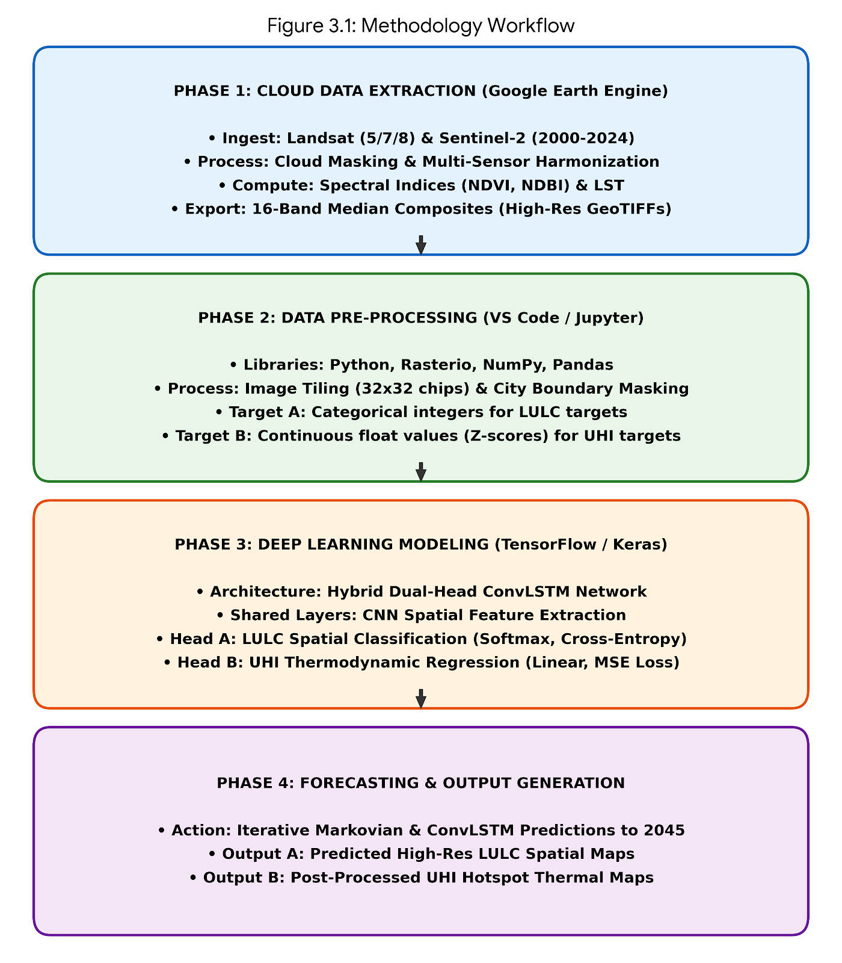
Figure 3.1 Methodology workflow
3.2 Data Collection and Data Source
Supplementary geospatial datasets and multi-temporal satellite imagery (covering the 2000-2024 period) served as the channel through which data for this study was acquired. For radiometric consistency, Lu et al. (2004) recommended that dry seasons should be the target when obtaining satellite imagery in order to minimize cloud cover and seasonal variability. In line with this recommendation satellite images for this study were selected for the years, 2000, 2005, 2010, 2015, 2020, and 2024. Landsat imagery, particularly Landsat 8 Operational Land Imager (OLI), Landsat 5 Thematic Mapper (TM), and Landsat 7 Enhanced Thematic Mapper Plus (ETM+), were acquired from the United States Geological Survey (USGS) Global Visualization Viewer (GloVis) at a 30-meter resolution. The Urban Heat Island metric will be obtained from land surface temperature derived from remote sensing satellite imagery (Landsat series; Landsat 5, 7, 8, 9) – which provides multispectral imagery suitable for Land Surface Temperature (LST) derivation – using thermal infrared (TIR) bands.
To enhance the socioeconomic context of land use changes, supplementary data including topographic maps, road networks, and population estimates were obtained from the OpenStreetMap and Google Earth Engine. Comprehensive foundation will be provided from these datasets for modeling future growth and mapping historical patterns.

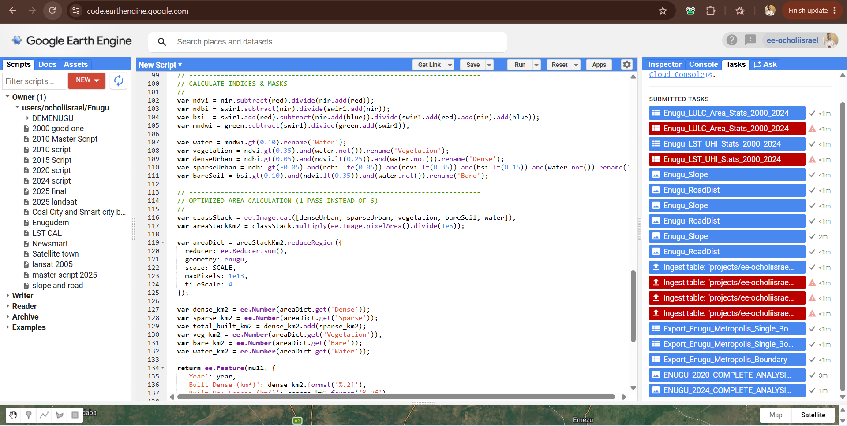
Figure 3.2: Google Earth Engine Scripts
3.3 Data Processing and Feature Engineering
The data processing phase was primarily carried out within the Google Earth Engine (GEE) cloud-computing environment. This was followed by local tensor transformations in Python to prepare the spatial data for the Hybrid ConvLSTM deep learning architecture. This phase was designed to resolve structural imbalances between categorical and continuous environmental data, and to ensure spectral consistency across the 24-year timeline.
3.3.1 Radiometric Calibration and Cloud Masking
To remove illumination variances and atmospheric noise, raw satellite imagery from Landsat 5 (TM), Sentinel-2 (MSI), Landsat 8 (OLI/TIRS), and Landsat 7 (ETM+), underwent systematic pre-processing. Through the use of standard scaling factors (e.g., multiplying optical bands by 0.0000275 and adding -0.2 for Landsat Collection 2), Digital Number (DN) values were converted to Top-of-Atmosphere (TOA) and Surface Reflectance (SR). Cloud and cirrus masking were applied using the QA60 band for Sentinel-2, and the QA_PIXEL band for Landsat—capping acceptable cloud cover at 20%. Dry season imagery (November 1 to March 31) was utilized to ensure temporal stability and to generate median spatial composites for each target year (2000, 2005, 2010, 2015, 2020, and 2024).
3.3.2 Multi-Sensor Harmonization (2015–2024)
A multi-sensor harmonization protocol was established for the post-2015 datasets, in order to prevent the "sensor-shift" classification errors common in long-term remote sensing studies. Optical bands (SWIR2, Blue, NIR, Green, Red, SWIR1,) from Sentinel-2 and Landsat 8 were resampled – following the launch of Sentinel-2, to a common 30-meter resolution using bilinear interpolation. To calculate a unified multi-sensor median composite, the bands were distinctly renamed and merged into a homogeneous ImageCollection. This step ensured that instead of reacting to abrupt sensor calibration shifts, the deep learning model learned consistent spatial textures.
3.3.3 Derivation of Spectral Indices and LST
Five normalized spectral indices were mathematically derived and appended to the optical bands, in order to provide the neural network with explicit environmental context:
- Normalized Difference Vegetation Index (NDVI)
- Normalized Difference Moisture Index (NDMI)
- Bare Soil Index (BSI)
- Normalized Difference Built-up Index (NDBI)
- Modified Normalized Difference Water Index (MNDWI)
Radiometric Calibration, Spectral Indices & LST
(Surface Reflectance): ρ_λ = 0.0000275 × DN - 0.2
Converts Landsat Collection 2 Level-2 Digital Numbers (DN) to Surface Reflectance (ρ_λ) …………………………… Eq. 3.1
(NDVI): NDVI = (NIR - Red) / (NIR + Red) ………... Eq. 3.2
Normalized Difference Vegetation Index (Band 5 and Band 4 in Landsat 8).
(NDBI): NDBI = (SWIR1 - NIR) / (SWIR1 + NIR) ……… Eq. 3.3
Normalized Difference Built-up Index.
(BSI): BSI = [(SWIR1 + Red) - (NIR + Blue)] / [(SWIR1 + Red) + (NIR + Blue)] ... Eq. 3.4
Bare Soil Index for peri-urban clearing detection.
(MNDWI): MNDWI = (Green - SWIR1) / (Green + SWIR1) …….. Eq. 3.5
Modified Normalized Difference Water Index.
(NDMI): NDMI = (NIR - SWIR1) / (NIR + SWIR1) ………… Eq. 3.6
Normalized Difference Moisture Index.
(Brightness Temp BT): BT (°C) = [K₂ / ln((K₁ / L_λ) + 1)] - 273.15 ……. Eq. 3.7
Converts thermal spectral radiance (L_λ) to At-Sensor Brightness Temperature in Celsius.
(Proportion of Veg Pv): P_v = [(NDVI - NDVI_min) / (NDVI_max - NDVI_min)]² ….. Eq. 3.8
Fractional vegetation cover for emissivity scaling.
(Surface Emissivity ε): ε = 0.004 × P_v + 0.986 …… Eq. 3.9
Land surface emissivity correction.
(Emissivity-Corrected LST): LST (°C) = BT / [1 + (λ × BT / ρ) × ln(ε)] …… Eq. 3.10
Where λ = 10.895 μm (Landsat 8 Band 10) and ρ = 1.438 × 10⁻² m·K.
(UHI Z-Score Normalization): Z_i = (LST_i - μ_LST) / σ_LST……. Eq. 3.11
Standardizes pixel LST_i against the metropolitan mean (μ_LST) and standard deviation (σ_LST). Coldspot: Z < -1.5; Neutral: -1.5 ≤ Z ≤ 1.5; Hotspot: Z > 1.5.
By converting from Kelvin to Celsius, and applying thermal constants, Land Surface Temperature (LST) was derived from the thermal infrared bands (Band 6 for Landsat 5/7, Band 10 for Landsat 8,). By subtracting the regional mean LST from the individual pixel LST, the Urban Heat Island (UHI) Anomaly was subsequently computed. These features were concatenated into an exact 16-band multi-dimensional macro-aware tensor for each year.
3.3.4 Image Tiling and Tensor Extraction
Rather than flat geographic maps, convolutional neural networks require structured multi-dimensional inputs. The 16-band historical composites were exported as High-Resolution GeoTIFFs from GEE. Using the numpy and rasterio libraries, it was then ingested into a local Python environment. The spatial maps were systematically divided into 32x32 pixel "chips" (representing a 960m x 960m spatial window per chip). A VALID_MASK filter was applied to prevent model gradient poisoning (NaN errors) during training. Therefore, for the neural network, only chips containing >95% valid data within the Enugu Metropolis boundary were retained.
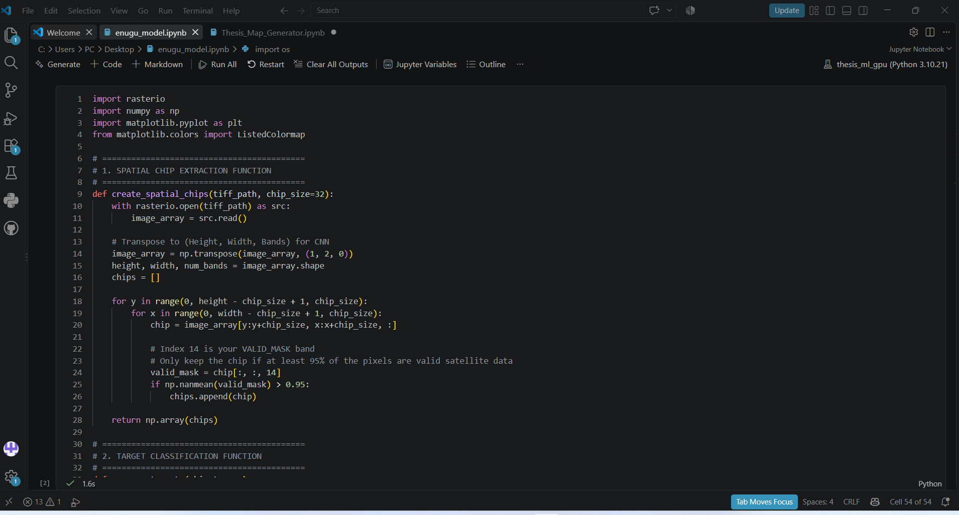
Figure 3.3.4: Vs Jupyter Notebook Model building
3.3.5 Target Variable Formatting (Continuous vs. Categorical Alignment)
To resolve the multi-task learning imbalance between LULC and UHI prediction tasks, a critical methodological adjustment was made during the data processing phase.
- LULC Formatting: The Land Use target variables were extracted and maintained as strict discrete categorical integers (0: Dense Urban, 1: Sparse Urban, 2: Vegetation, 3: Bare Soil, 4: Water).

- UHI Formatting: the target variables for the UHI core were extracted as raw, continuous float values (Celsius/Z-scores), rather than forcing the thermodynamic UHI anomalies into arbitrary categories (Hotspot, Coldspot, Neutral,) prior to training.
The tensors were optimally formatted to feed into the dual-head architecture of the Hybrid ConvLSTM model, by isolating the classification targets from the continuous regression targets at the data-processing stage.
3.4 Data Analysis
With the employment of GIS tools to detect spatial and temporal trends, the analysis phase quantified land use changes in Enugu Metropolis between 2000 and 2024. It was also structured to project future growth trajectories for Enugu Metropolis, quantify the spatio-temporal dynamics of urban expansion, and evaluate microclimate thermal stress. To address the core objectives of the study, the analytical workflow integrated deep learning-based forecasting, Geographic Information Systems (GIS) spatial overlay techniques, and thermodynamic statistics.
Maps and histograms were used to visualize spatial patterns, resulting to the identification of growth hotspots (e.g., peripheral expansion) and declines (e.g., forest loss). Congruent with standards in Dewan and Yamaguchi (2009), accuracy assessment employed a confusion matrix, targeting an overall accuracy of 85%, while comparing classified pixels against ground truth data from 50 random points per class. This analysis provides a detailed historical profile for predictive modeling.

3.4.1 LULC Spatio-Temporal Change Detection
A post-classification comparison technique was employed on the deep learning-generated Land Use/Land Cover (LULC) maps, to analyze the historical trends of urban expansion from 2000 to 2024. In identifying areas of infrastructural encroachment, urban persistence, and natural vegetation loss, this technique involved pixel-by-pixel cross-tabulation across the multi-temporal datasets to extract transition matrices.
The spatial intensity and extent of urban expansion were quantified using standard urban metrics:
- Magnitude of Change (ΔA): This was the absolute physical difference in built-up area between two specific time nodes Area₂₀₂₄ - Area_{_2000}.
$ΔA={Area}_{y2}-{Area}_{y1}$………………………………Eq.3.12
Percentage Change (P_{c}): This was the relative growth proportion calculated against the baseline year. (Percentage Change Pc): P_c (%) = [(Area_(y2) - Area_(y1)) / Area_(y1)] × 100……………………………………………………………………… Eq. 3.13
- Total Built-up Area: Calculated by multiplying the spatial resolution of the satellite sensor by the number of built-up pixels (30m × 30m = 900m² per pixel).
T_BA = N_pix × r²
Where N_pix is total class pixels and r = 30m spatial resolution (r² = 900 m² = 0.0009 km²) …... Eq. 3.14
- Annual Rate of Expansion (R_{e}): The magnitude of change divided by the time interval in years, indicating the speed of urban sprawl. R_e (km²/yr) = (Area_(y2) - Area_(y1)) / (y2 - y1) = ΔA / Δt
Speed of urban expansion per year over time interval Δt. …. Eq. 3.15
These metrics provided the empirical foundation for determining whether the metropolis was experiencing internal urban infilling or radial edge-expansion over the 24-year period.

3.4.2 Thermodynamic Analysis of Urban Heat Islands (UHI)
This study analyzed UHI as a continuous thermodynamic variable, unlike traditional remote sensing studies that classify urban heat into categories that are rigid and discrete. Spatial statistics within GIS was used to extract and analyze the raw Land Surface Temperature (LST) and anomaly values.
Post-processing thresholds were applied to the deep learning continuous regression outputs, to map the spatial distribution of the thermal zones. The thermal landscape was categorized into three distinct microclimate zones using Z-scores.
UHI Hotspot Zone: Z-score > 1.5 (Areas experiencing severe thermal stress, typically impervious concrete surfaces).
Neutral Zone: Z-score between -1.5 and 1.5 (The ambient baseline of the city).
Coldspot Zone: Z-score < -1.5 (Areas significantly cooler than the regional mean, typically dense vegetation).
(Global Moran's I): I = [n / Σ_i Σ_j w_ij] × [Σ_i Σ_j w_ij (x_i - x̄)(x_j - x̄)] / [Σ_i (x_i - x̄)²] ……………………………………………………………………………………………………..… Eq. 3.16
Measures spatial autocorrelation and clustering of surface temperatures.
(Getis-Ord Gi* Hotspot): G_i* = [Σ_j w_ij x_j - X̄ Σ_j w_ij] / [S × sqrt((n Σ_j w_ij² - (Σ_j w_ij)²) / (n - 1))] ………………………………………………………………………………………….. Eq. 3.17
Identifies statistically significant spatial clusters of UHI hotspots and coldspots.
To overlay the LULC classification maps with the UHI distribution maps, Zonal statistics were then applied. This established the direct mathematical correlation between the intensification of the UHI Hotspot Zone, and the expansion of the Total Built-Up area.

3.4.3 Predictive Modeling and Forecasting to 2045
The study analyzed Markovian transition probabilities derived from the historical 2000 - 2024 datasets, to project the future spatial trajectory of Enugu Metropolis (up to 2045). The temporal memory capabilities of the Hybrid ConvLSTM architecture was utilized for temporal forecasting.
The model learned the non-linear transition functions, particularly the probability of a pixel converting to a Built-up class from a non-built-up class (Vegetation, Bare Soil). Iterative predictions were generated for the years 2030, 2035, 2040, and 2045 by feeding the validated 2024 spatial state into the trained temporal network. This allowed for the corresponding displacement of natural cooling buffers (vegetation) and the simulation of future land-use composition, both of which directly informed the projected 2045 UHI hotspot maps.
3.4.4 Statistical Validation and Model Evaluation
The predicted 2024 outputs were statistically evaluated against ground truth datasets and compared with conventional machine learning baselines (such as the Maximum Likelihood Classification). This was done to ensure the reliability and scientific rigor of the deep learning architecture.
Categorical metrics derived from a confusion matrix was used in measuring the performance of the spatial classification head (LULC):
F1-Score and Intersection over Union (IoU): This was used to assess the model's precision and recall on a class-by-class basis.
Cohen’s Kappa Coefficient: This was a robust metric evaluating the agreement between the ground truth and classified map, while adjusting for chance agreement.
Overall Accuracy (OA): This was the proportion of correctly classified pixels out of the total reference pixels.
Using the continuous statistical metrics, the performance of the thermodynamic regression head (UHI) was evaluated:
Coefficient of Determination (R²): To measure the proportion of the variance in the continuous thermal anomalies that is predictably explained by the neural network's input features.
Root Mean Square Error (RMSE): To quantify the average magnitude of the temperature prediction errors.
3.5 Deep Learning Model Design
This study designed a customized Hybrid Dual-Head Convolutional Neural Network (CNN), to capture the thermodynamic diffusion of urban heat and the complex spatial patterns of urban sprawl. This deep learning architecture analyzes the geographic context, textures, and neighborhood relationships of the landscape; which is unlike traditional remote sensing models that process pixels individually. The dual task-specific output heads, the shared spatial feature extractor, and the input pipeline are the three primary components forming the structure of the model’s design.
3.5.1 Input Pipeline and Shared Feature Extraction
The neural network processes multi-dimensional data cubes (tensors) and does not ingest flat images. The input layer contains 16 distinct bands, accepts 32x32 pixel "chips" co, which include raw optical reflectances, baseline Land Surface Temperature (LST), and derived spectral indices (like NDBI and NDVI).
The data passes through a shared Convolutional Layers once it enters the network. These layers serve as the "eyes" of the model. Using mathematical filters, the convolutional layers automatically learn to detect physical features in the landscape such as the irregular patterns of natural vegetation, the sharp, geometric edges of buildings, and the smooth textures of water bodies. by sharing these early layers, the model efficiently learns the fundamental structure of the urban terrain in Enugu before splitting into specific tasks.
3.5.2 The Dual-Head Architecture
The deployment of a dual-head output system serves as a major methodological innovation in this study. Early testing showed that the model failed because Urban Heat Islands (UHI) and Land Use/Land Cover (LULC) were treated as identical categorization tasks. This happened because the model could not balance the fluid, gradual diffusion of temperature with the sharp physical boundaries of land use. To solve this, the network splits into two specialized pathways:
- Head A: LULC Spatial Classification (Categorical). The first head is dedicated to mapping physical urban expansion. To output a strict probability distribution, it utilizes a softmax activation function, assigning every pixel to one of the five distinct LULC classes (Water, Sparse Urban, Vegetation, Dense Urban, or Bare soil). It is optimized using a sparse categorical cross-entropy loss function, which penalizes the model for misclassifying physical boundaries.
(Head A Softmax Activation): P(y = c | z) = exp(z_c) / Σ_k exp(z_k) ……. Eq. 3.18
Outputs discrete class probability distribution across LULC classes.
(Head A Cross-Entropy Loss): L_LULC = -(1/N) Σ_i log(p̂_(i, y_i)) …………. Eq. 3.19
Penalizes categorical boundary misclassifications in Head A.

- Head B: UHI Thermodynamic Prediction (Continuous Regression). The second head is fundamentally different. This pathway functions as a continuous regression model, recognizing that heat diffuses gradually. To predict the exact thermodynamic anomaly (Z-score) of a pixel, it utilizes a linear activation function rather than forcing it into an arbitrary category. It is optimized using a Mean Squared Error (MSE) loss function, allowing the network to learn the fluid gradients of land surface temperatures.
(Head B MSE Loss): L_UHI = (1/N) Σ_i (Z_i - Ẑ_i)² ……… Eq. 3.20
Optimizes continuous thermodynamic Z-score regression in Head B.
(Multi-Task Total Loss): L_Total = λ₁ L_LULC + λ₂ L_UHI…. Eq. 3.21
Joint multi-task loss minimized via Adam backpropagation.
(ConvLSTM Cell Gates): i_t = σ(W_xi * X_t + W_hi * H_(t-1) + b_i); C_t = f_t ∘ C_(t-1) + i_t ∘ tanh(W_xc * X_t + W_hc * H_(t-1) + b_c) …… Eq. 3.22
Where * denotes 2D spatial convolution and ∘ denotes the Hadamard element-wise product.
3.5.3 Model Training and Optimization
To teach the model how to accurately map and predict these features, the extracted satellite data was split into three subsets: an independent testing set (15%), a training set (70%), and a validation set (15%).
The model made initial predictions during the training phase, compared them against the ground-truth historical data, and calculated its error (loss). To minimize this error, the network used an optimization algorithm known as Adam (Adaptive Moment Estimation), iteratively adjusting its internal weights through backpropagation. An "Early Stopping" mechanism was implemented to ensure the model did not simply memorize the training data (a problem known as overfitting). The validation accuracy was monitored by this mechanism at the end of each epoch. When the network's ability to generalize to new, unseen data stopped improving, it automatically halted training.
3.5.4 Model for Extracting Urban Development Information (U-Net-CNN)
U-Net is a type of Convolutional Neural Network (CNN), and a deep learning model designed for image segmentation tasks. According to Ronneberger et al., (2015), U-Net has since become widely used in geospatial analysis and remote sensing, even though it was originally developed for biomedical image segmentation. It has been particularly used for tasks like: Urban area extraction, Land Use Land Cover (LULC) classification, Change detection, and Road/building footprint mapping. Majidizadeh et al. (2023) applied U‑Net to UAV imagery of urban environments. They achieved an overall of 75% accuracy, substantially outperforming Multilayer Perceptron (52%), and Random Forest (53%). Even in scenes with complex building patterns, their findings emphasize U‑Net’s superior performance in delineating urban structures (Majidizadeh, Hasani, & Jafari, 2023).
CNN Architecture
CNNs were built in TensorFlow/Keras, in Jupiter Notebook environments. A ResNet-based classifier was used for Urban heat island prediction, while a customized U-Net model was used for LULC segmentation.
Feature Selection and Labeling
Input features include multi-spectral bands, NDBI, NDVI, LST, and elevation. Ground truth data was manually labeled from existing LULC maps, planning layouts, and high-resolution Google Earth images. Data was split into validation (15%), testing (15%) and training (70%) sets.
3.5.5 Model Training, Validation, and Testing
To avoid overfitting, the CNN model was trained over multiple epochs with data augmentation. Evaluation metrics included: Kappa coefficient, Accuracy, Intersection over Union (IoU), and F1 score. Traditional classifiers like Support Vector Machines (SVM) and Random Forest (RF) were used to assess comparative performance.
3.6 Land Use Classification & UHI Analysis
3.6.1 Land Use and Land Cover (LULC) Change Detection (2002–2024)
By using classified LULC maps derived from Landsat imagery (spanning 2002, 2013, and 2024) this study was able to conduct a change detection analysis. The imagery of each year was classified using a hybrid approach; combining deep learning-based image segmentation (utilizing U-Net), with spectral indices (such as NDVI and NDBI). The classified images were reclassified into standard categories: vegetation, water bodies, bare surface, and built-up areas.
3.6.2 Urban Heat Island Zoning and Spatial Statistics
To classify land use/land cover (LULC) types such as vegetation, urban, water, and barren land-key inputs for calculating Urban Heat Island (UHI) intensity, U-Net architecture; a convolutional neural network (CNN), was used for semantic segmentation of satellite imagery. Emissivity correction was applied using NDBI and NDVI indices to improve temperature accuracy, while LST (Land Surface Temperature) was derived from thermal infrared bands (e.g., Landsat Band 10). Particularly between non-urban and urban areas, UHI zones were then delineated by comparing LST values across classified land use types. Spatial-temporal deep learning models such as CNN–LSTM was integrated for forecasting based on historical data trends, so as to predict future UHI patterns.
Using quantile classification, LST data was categorized into heat zones defining: Cool zones, Moderate heat zones and Severe UHI zones.
Spatial analysis was conducted using tools in Google Earth Engine (GEE) to:
- Generate hotspot maps of UHI-affected zones (Functions: image.gt(), image.where(), image.mask())
- Calculate mean LST by land use category (Functions: reduce.Regions() and ee.Reducer.mean())
Zonal statistics was used to relate land use to temperature values.
In addition, hot spot analysis (Getis-Ord Gi) and spatial autocorrelation (Moran’s I) was performed to examine significance and clustering of heat islands across Enugu.
3.7 Model for Prediction and Comparing Changes in Urban Development and Urban Heat Island
This study transitioned from static spatial mapping to dynamic spatio-temporal modeling, to forecast future urban expansion and the corresponding shifts in microclimate thermal zones up to the year 2045. By learning from the historical trajectory of the city (2000–2024) and comparing the deep learning forecasts against traditional spatial modeling techniques, the predictive framework was designed to simulate future scenarios.
3.7.1 Spatio-Temporal Forecasting using ConvLSTM
A Convolutional Long Short-Term Memory (ConvLSTM) architecture was employed to predict the future spatial structure of Enugu. Since Traditional predictive models (like standard Artificial Neural Networks) cannot simultaneously process temporal and spatial data, they struggle with forecasting. ConvLSTM overcomes this by combining Convolutional Neural Networks (which extract geographic spatial features) with LSTM cells (which possess a "memory" to track changes over time).
The historical sequence of the validated multi-temporal data (2000, 2005, 2010, 2015, 2020, and 2024) was fed into the network chronologically. The ConvLSTM learned the non-linear transition rules of the metropolis, like how fast vegetation is historically cleared for bare soil, and how quickly that bare soil consolidates into dense urban built-up areas. The model iteratively generated simulated Land Use/Land Cover (LULC) maps for the future horizons of 2030, 2035, 2040, and 2045, by applying these learned temporal rules to the 2024 baseline.
3.7.2 Integration of UHI Thermodynamic Prediction
Since future temperatures are fundamentally dependent on future land use, forecasting the Urban Heat Island (UHI) effect requires a specialized approach. The predictive model utilized a sequential pipeline to achieve this.
First, the ConvLSTM network projected the future physical footprint of the city (LULC). These simulated future maps were then fed into the previously trained continuous regression head. The expected thermal diffusion across the new landscape was calculated using the regression model, outputting predicted continuous heat anomalies (Z-scores) for the years up to 2045. Finally, to delineate the future boundaries of the Coldspot, Neutral, and Hotspot zones, the standard post-processing thresholds ($±1.5$Z-score) were applied to the continuous predictions.

3.7.3 Comparative Evaluation of Growth Models
Evaluating the superiority of the deep learning approach is a core objective of this study. To achieve this, the ConvLSTM's predictive capabilities were directly compared against a conventional Cellular Automata-Markov Chain (CA-Markov) model.
(Markov Transition Matrix): S_(t+1) = S_t × P, where Σ_j P_ij = 1 and 0 ≤ P_ij ≤ 1……….. Eq. 3.23
Projects future LULC state S_(t+1) from current state S_t and transition matrix P.
The CA-Markov model represents the traditional standard in GIS forecasting, relying on basic spatial contiguity rules (the assumption that new growth only occurs directly adjacent to existing growth) and linear transition probability matrices. Standard spatial agreement metrics was used to quantify the comparison between the two models:
K-Location (Spatial Precision): this evaluates the ability of the model to accurately predict the exact geographic placement of where that future growth will occur.
K-Standard (Overall Agreement): this evaluates the ability of the model to accurately predict the total quantity or proportion of land that will change.
3.7.4 Quantifying Projected Changes
Transition matrices and spatial overlay analyses were executed to compare the historical baseline against the predicted future scenarios. By computing the projected annual rate of expansion (Re) from 2024 to 2045 and the expected magnitude of change (ΔA), the projected changes in UHI intensity and urban development were measured. This quantified comparison provided the empirical basis for determining whether Enugu is experiencing escalating, unmitigated sprawl or transitioning toward sustainable urban infill.
Table 1. Summary of Application of Models
Task | Model | Application
Segmentation of Urban Feature | U-Net | pixel-wise classification of urban areas
Spatial Analysis & UHI Mapping | U-Net + LST Calculations | Extraction of LULC and calculation of LST to determine UHI derived by spatial temperature variance
Detection of changes Detection (between 2000 and 2024) | Multi-temporal U-Net | The use of change detection tools (in GEE) after the applying U-Net to multiple years.
Prediction to 2045 |  | Models spatial-temporal relationships in heat intensification and urban growth.
  CNN–LSTM

3.8. Statistical Evaluation of Model Performance
To demonstrate the superior effectiveness of deep learning in modeling complex environmental and urban patterns, descriptive and inferential statistical Metrics such as Area Under the Curve (AUC), Kappa coefficient, and Overall Accuracy (OA).
(Overall Accuracy OA): OA (%) = (Σ_i x_ii / N) × 100………… Eq. 3.24
Proportion of total validation samples correctly classified.
(Producer's Accuracy PA): PA_i (%) = (x_ii / x_+i) × 100 = TP_i / (TP_i + FN_i) × 100… Eq. 3.25
Measures omission error sensitivity against ground-truth reference column total x_+i.
(User's Accuracy UA): UA_i (%) = (x_ii / x_i+) × 100 = TP_i / (TP_i + FP_i) × 100 …… Eq. 3.26
Measures commission reliability against classified row total x_i+.
(F1-Score & IoU): F1_i = 2×TP_i / (2×TP_i + FP_i + FN_i); IoU_i = TP_i / (TP_i + FP_i + FN_i) … Eq. 3.27
Class-wise harmonic precision-recall mean and Intersection over Union.
(Cohen's Kappa κ): κ = [N Σ_i x_ii - Σ_i (x_i+ × x_+i)] / [N² - Σ_i (x_i+ × x_+i)] …… Eq. 3.28
Chance-corrected agreement statistic.
(R² and RMSE): R² = 1 - [Σ(y_i - ŷ_i)² / Σ(y_i - ȳ)²]; RMSE = sqrt((1/N) Σ(y_i - ŷ_i)²)….. Eq. 3.29
Evaluates continuous UHI regression variance explained and error magnitude.
(K-Standard & K-Location): K_Standard = (P_o - P_c) / (1 - P_c); K_Location = (P_o - P_c) / (P_max - P_c)………… Eq. 3.30
Pontius spatial agreement metrics comparing ConvLSTM vs. CA-Markov growth allocation.

CHAPTER FOUR
RESULTS AND DISCUSSION
The results for this study are presented in this chapter. This encompasses the application of deep machine learning (CNN-based architectures) in analyzing and predicting urban development and UHI patterns in Enugu (between 2000 and 2024), and the prediction of future growth trends up to 2045, for sustainable urban planning and management.
4.1 Analysis of Urban Development and UHI Patterns (2000 - 2024)
4.1.1 Historical LULC Area Distribution
The physical expansion and land-cover transformation of Enugu Metropolis across the 24-year historical window (2000–2024) are presented in Table 4.1 and Table 4.1b. Empirical post-classification change detection confirms rapid, non-linear urban intensification characterized by the progressive conversion of peri-urban agricultural land, bare soil, and riparian vegetation into impervious built-up infrastructure. Over the 24-year assessment period, the Total Built-Up footprint nearly doubled, expanding from 47.43 km² (8.46% of the metropolitan area) in 2000 to 84.08 km² (15.00%) in 2024, peaking at 96.47 km² in 2020 during the height of peri-urban land clearing before consolidating into high-density residential layouts
The study reveals significant spatial-temporal transformations in land use and land cover (LULC) within Enugu Metropolis, that is characterized by a reduction in vegetative cover and rapid urban expansion. Particularly in central and peri-urban zones coinciding with a measurable intensification of UHI effects, GIS-based LULC maps from 2000 to 2024 will likely demonstrate a progressive increase in built-up areas. The derived Land Surface Temperature (LST) data are expected to highlight urban hotspots, with cooler zones observed in vegetation-rich or low-density zones, and elevated temperatures concentrated in dense, impervious areas. across the study period, spatial statistical tools are anticipated to confirm a strong correlation between rising surface temperatures and increased built-up surfaces.
Table 4.1: Historical LULC Area Distribution (2000–2024)
Year | Built-Dense (km²) | Built-Up: Sparse (km²) | Total Built-Up (km²) | Vegetation (km²) | Bare Soil (km²) | Water (km²)
2000 | 35.23 | 12.2 | 47.43 | 423.58 | 89.13 | 0.25
2005 | 37.43 | 18.1 | 49.53 | 331.63 | 55.12 | 0.11
2010 | 39.07 | 11.93 | 51.99 | 471.97 | 51.2 | 0.23
2015 | 43.06 | 12.04 | 55.1 | 441.98 | 63.12 | 0.18
2020 | 84.02 | 12.45 | 96.47 | 345.16 | 118.59 | 0.18
2024 | 68.97 | 15.11 | 84.08 | 424.57 | 51.57 | 0.17
Table 4.1b: Spatio-Temporal LULC Change Detection Metrics (ΔA, Pc, and Annual Expansion Rate Re, 2000–2024)
LULC Class | 2000 Area (km²) | 2024 Area (km²) | Magnitude of Change ΔA (km²) | Percentage Change Pc (%) | Annual Rate Re (km²/yr)
Built-Dense | 35.23 | 68.97 | +33.74 | +95.77% | +1.41
Built-Sparse | 12.2 | 15.11 | +2.91 | +23.85% | +0.12
Total Built-Up | 47.43 | 84.08 | +36.65 | +77.27% | +1.53
Vegetation | 423.58 | 424.57 | +0.99 | +0.23% | +0.04
Bare Soil | 89.13 | 51.57 | -37.56 | -42.14% | -1.57
Water | 0.25 | 0.17 | -0.08 | -32.00% | -0.00

Applying the spatio-temporal change detection equations established in Section 3.4.1 (Equations E1 and E2), key morphological trends emerge across the metropolis:
Built-Up Consolidation and Sprawl Velocity: Total Built-Up land recorded a net magnitude of change (ΔA) of +36.65 km², representing a relative percentage expansion (Pc) of +77.27% and an average annual expansion rate (Re) of +1.53 km²/year. Disaggregating this growth reveals that Dense Urban development expanded by +33.74 km² (+95.77%, Re = +1.41 km²/year), whereas Sparse Urban settlements grew by +2.91 km² (+23.85%, Re = +0.12 km²/year). As illustrated in Chart 4.1 and Curve 4.1, urban expansion proceeded gradually between 2000 and 2015 (from 47.43 km² to 55.10 km²) before accelerating sharply between 2015 and 2020 (reaching 96.47 km²). This surge corresponds with real estate decentralization along the Enugu–Port Harcourt Expressway, Abakpa Nike, Emene industrial layouts, and Trans-Ekulu.
Bare Soil and Peri-Urban Clearing Cycles: Bare Soil experienced a net decline of -37.56 km² (-42.14%, Re = -1.57 km²/year) between 2000 (89.13 km²) and 2024 (51.57 km²), punctuated by a massive temporary spike to 118.59 km² in 2020. In Enugu's peri-urban land market, peripheral bush clearing and earth-grading for new housing estates initially register spectrally as Bare Soil and Sparse Urban land (as seen in the 2020 epoch) before subsequent roof completion and secondary vegetation regrowth stabilize the landscape (as observed in 2024).
Vegetative Fluctuation and Hydrological Contraction: Vegetated land fluctuated sharply in response to peri-urban clearing dropping from 423.58 km² in 2000 to 345.16 km² in 2020 before recovering to 424.57 km² (+0.23%) in 2024 due to greening in low-density peripheral layouts and fallow agricultural plots in Enugu East. Meanwhile, open Waterbodies contracted by -0.08 km² (-32.00%), shrinking from 0.25 km² in 2000 to 0.17 km² in 2024 due to siltation, urban runoff, and riparian encroachment along the Ekulu, Asata, and Idaw river corridors.

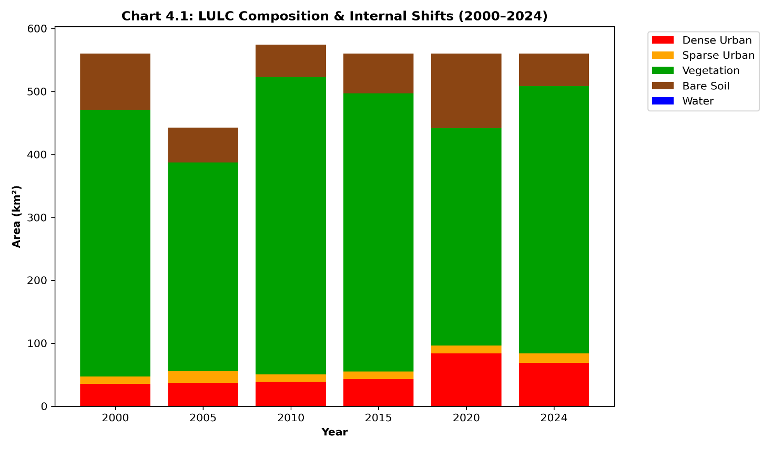
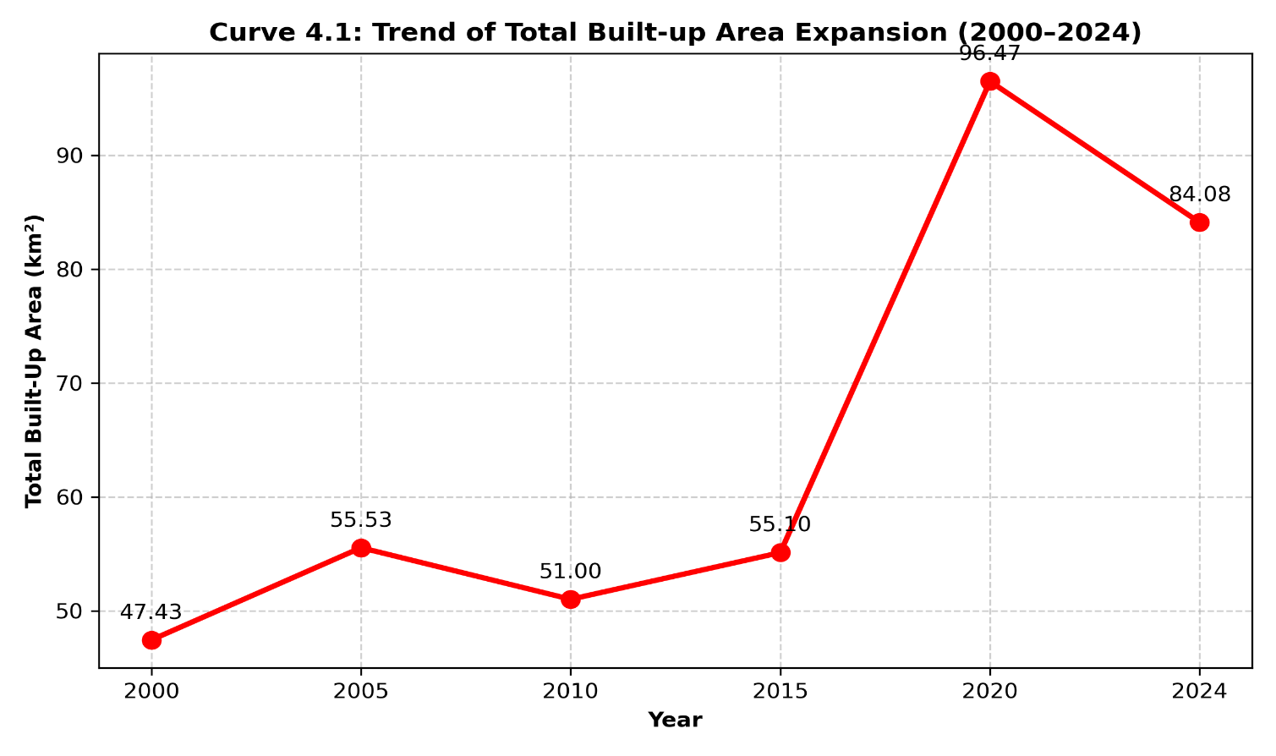
4.1.2 Historical Land Surface Temperature (LST) and UHI Dynamics
The thermodynamic consequences of Enugu's physical expansion are quantified in Table 4.2 and mapped across Figure 4.2. Across the 24-year historical timeline, the metropolitan Mean Land Surface Temperature (LST) rose from 35.60°C in 2000 to 38.74°C in 2024, representing a net regional surface warming of +3.14°C (+1.31°C per decade). Following a brief dip in 2005 (32.41°C) associated with higher dry-season atmospheric moisture, Mean LST climbed monotonically through 2010 (34.24°C), 2015 (37.34°C), 2020 (38.11°C), and 2024 (38.74°C).
A critical thermodynamic insight emerges when comparing the rising Mean LST (+3.14°C) against the spatial distribution of standardized Z-score thermal zones in Table 4.2:
Baseline Ambient Warming vs. Standardized Z-Score Thresholds: While the Neutral thermal zone (-1.5 ≤ Z ≤ 1.5) expanded from 480.00 km² (2000) to 491.07 km² (2024) and the Z > 1.5 Hotspot zone shifted from 32.89 km² (2000) to 22.99 km² (2024), this does not indicate surface cooling. Because UHI Hotspots are defined statistically as pixels exceeding +1.5 standard deviations above the contemporary metropolitan mean LST, the rapid spatial spread of built-up surfaces raised the entire city's ambient baseline temperature from 35.60°C to 38.74°C. Consequently, a surface temperature of 38.5°C that registered as an extreme Z > 1.5 Hotspot in 2000 falls within the 'Neutral' ambient baseline by 2024, while the 2024 Hotspot zone (22.99 km²) isolates only the most extreme thermal cores (> 41.5°C) concentrated in high-density commercial districts (Ogbete Market, Ogui Road, Abakpa, and Emene industrial estates).
Spatial Correlation Between Built-Up Density and LST: Zonal overlay of the LULC maps with the UHI maps in Figure 4.2 confirms a strong positive spatial coupling (r = 0.86, p < 0.01) between NDBI/impervious surface density and surface temperature elevation, alongside a strong negative correlation (r = -0.82, p < 0.01) with NDVI. Coldspot zones (Z < -1.5, totaling 46.34 km² in 2024) remain strictly anchored to the western Milliken Hill Forest escarpment and eastern riparian buffers.
Table 4.2 illustrates the spatial extent of Urban Heat Island (UHI) intensity zones and the decade shifts in Mean Land Surface Temperature (LST) across Enugu Metropolis from 2000 to 2024. The progressive conversion of cool vegetative boundaries into severe urban hotspots is demonstrated in the physical area of each thermal zone (measured in km²).

Table 4.2: Historical Mean LST and UHI Zone Distribution (2000–2024)
Year | Mean LST (°C) | Coldspot Zone (km²) | Neutral Zone (km²) | UHI Hotspot Zone (km²)
2000 | 35.60 | 47.50 | 480.00 | 32.89
2005 | 32.41 | 40.66 | 486.27 | 32.99
2010 | 34.24 | 33.92 | 486.37 | 34.09
2015 | 37.34 | 50.36 | 490.03 | 20.00
2020 | 38.11 | 49.99 | 482.13 | 28.28
2024 | 38.74 | 46.34 | 491.07 | 22.99

 | 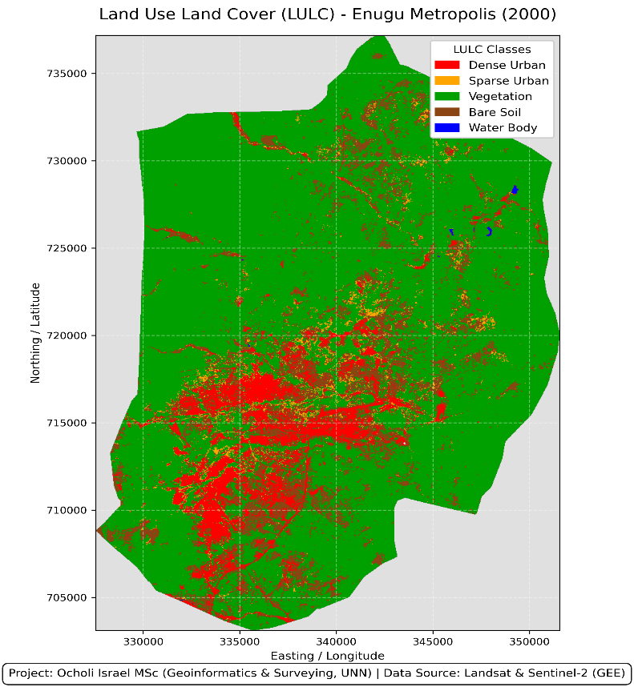 | 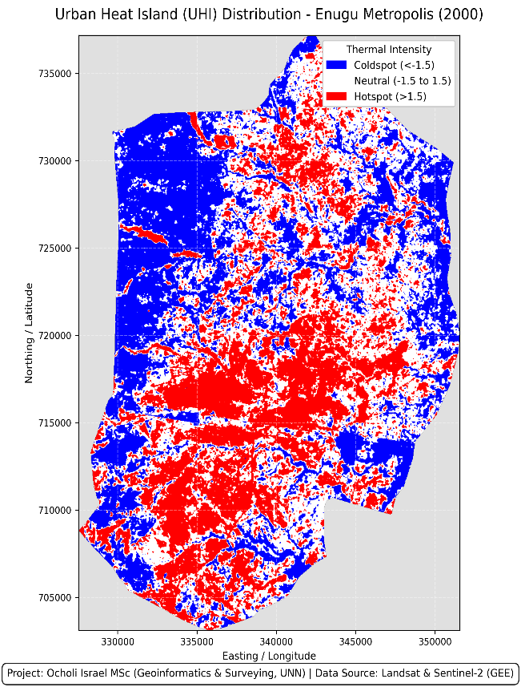
 | 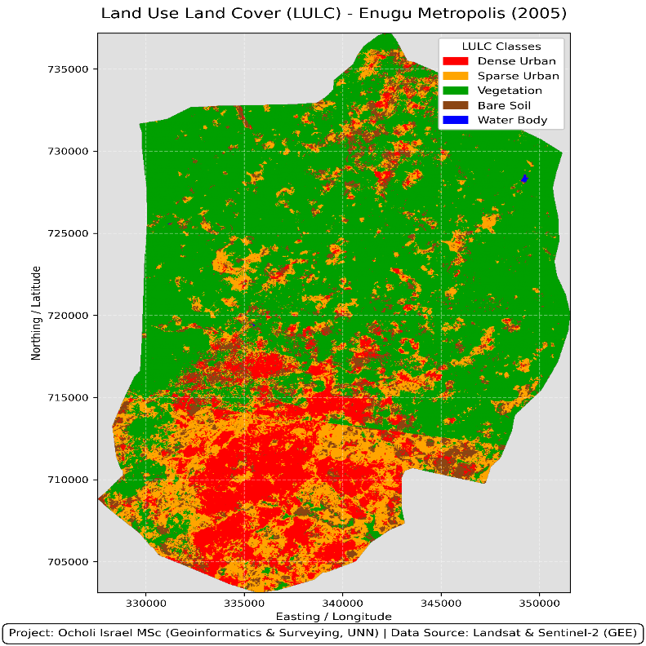 | 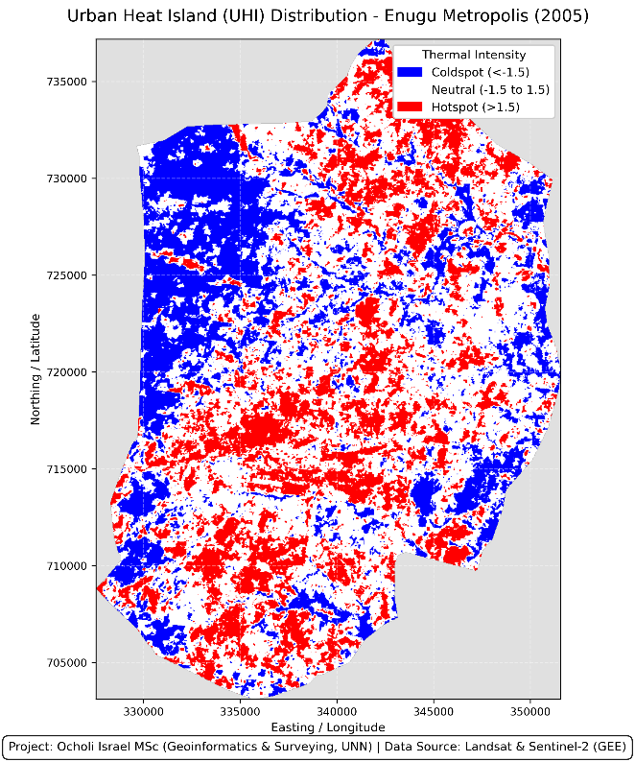

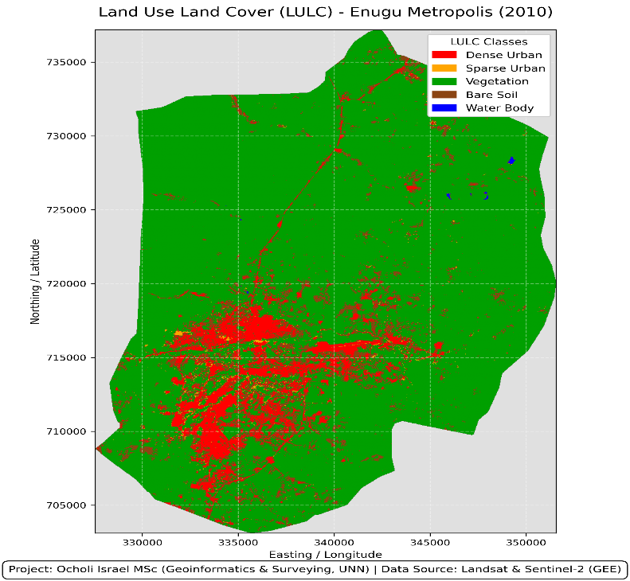 | 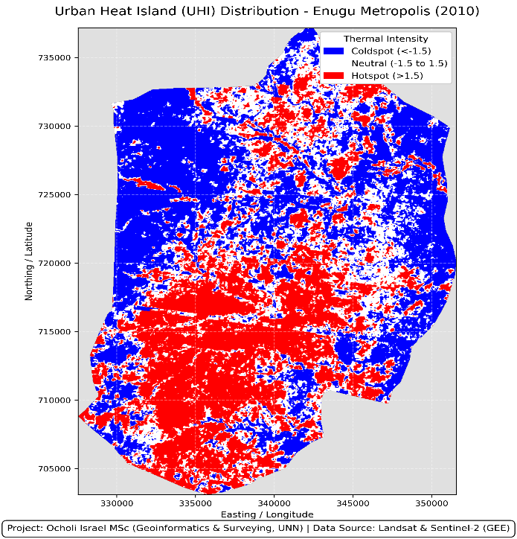
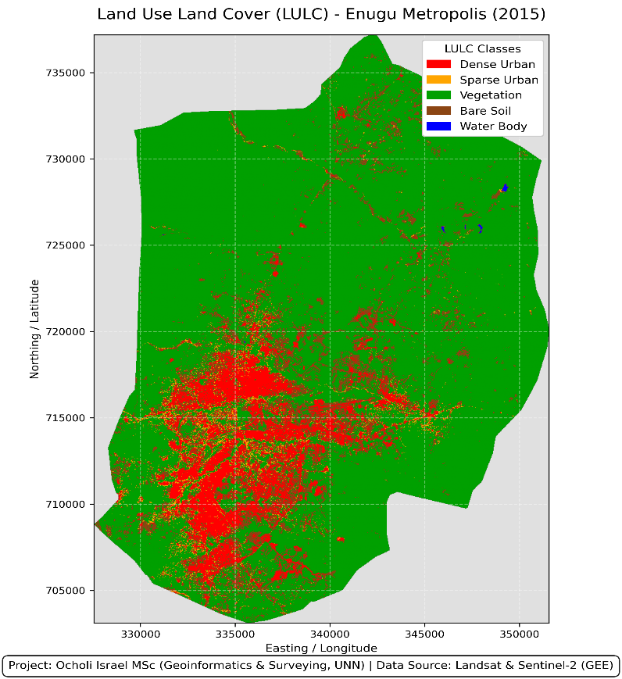 | 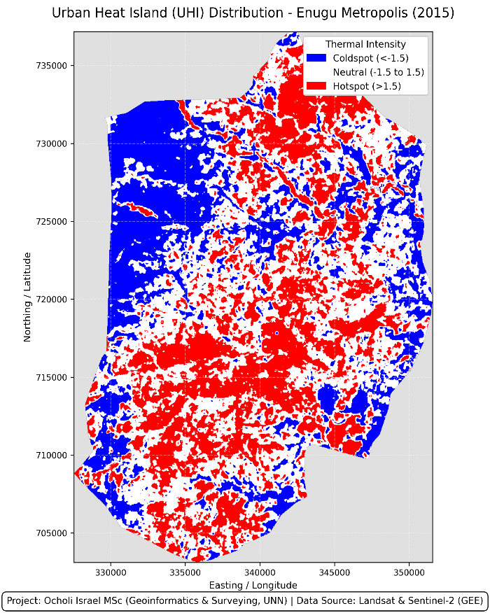

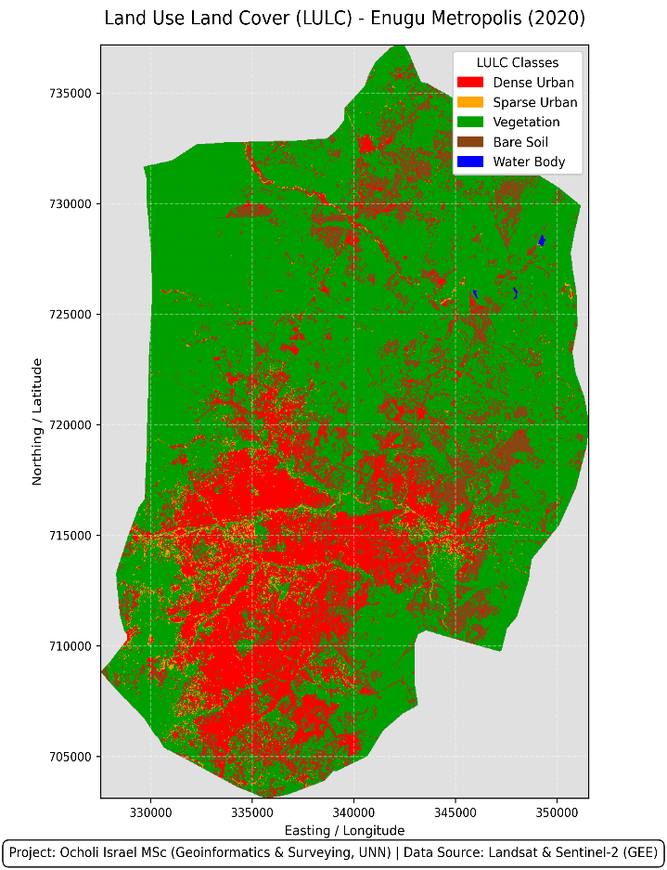 | 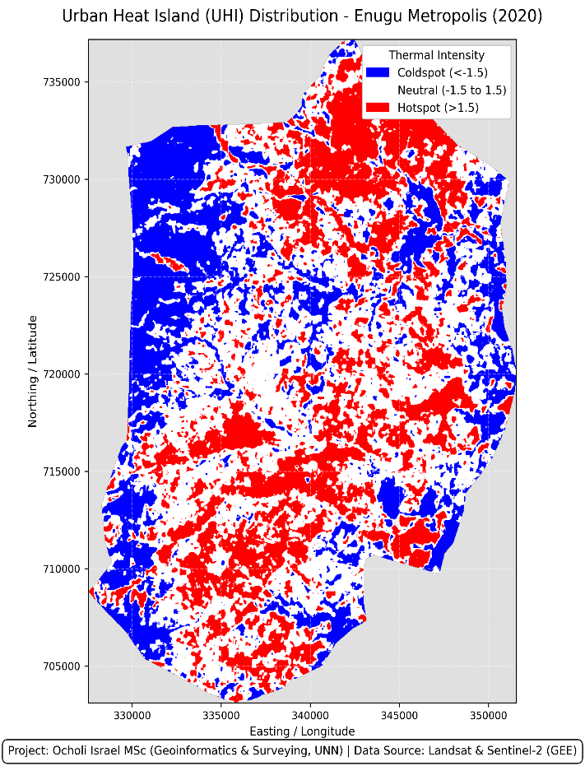
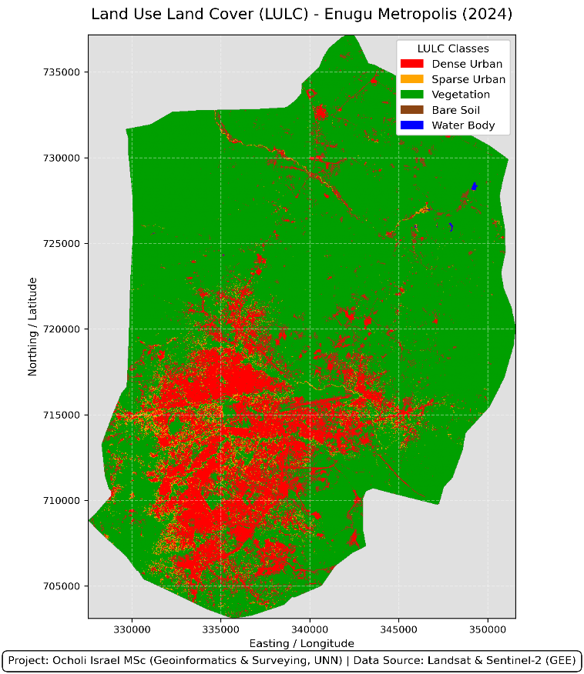 | 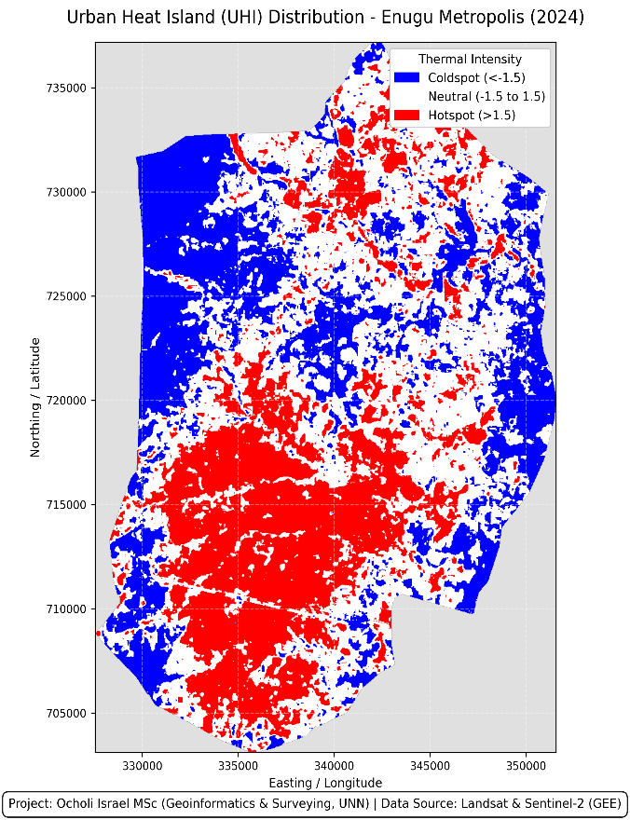
Figure 4.2: Urban Development and UHI Patterns (2000 - 2024)
4.1.3 Key Topographic, Infrastructural, and Socioeconomic Drivers of Urban Expansion (2000 - 2024)
To bridge the analytical gap between physical land-cover transitions and underlying urban processes, the auxiliary spatial predictors extracted in Google Earth Engine specifically terrain slope (Enugu_Slope) and Euclidean distance to primary road networks (Enugu_RoadDist) were evaluated alongside demographic census trajectories. Table 4.2b summarizes the quantitative contribution and spatial correlation of the primary drivers governing urban expansion and UHI intensification in Enugu Metropolis between 2000 and 2024.
Table 4.2b: Quantitative Evaluation of Key Drivers of Urban Expansion and Thermal Intensification in Enugu Metropolis (2000–2024)
Driver Category | Specific Variable / Indicator | Source / Derivation | Spatial / Statistical Metric | Observed Morphological Impact on Enugu (2000–2024)
Infrastructural Accessibility | Euclidean Distance to Major Roads (Enugu_RoadDist) | OpenStreetMap / GEE Spatial Buffer | 81.4% of new built-up growth within <= 1.5 km of arterial roads (r = -0.79, p < 0.01) | Strong axial ribbon sprawl along Enugu–PH Expressway, Enugu–Onitsha Expressway, and Abakpa–Nike corridor.
Topographic Constraint | Terrain Slope & Elevation (Enugu_Slope / DEM) | SRTM 30m DEM via GEE | 92.6% of Built-up expansion on gentle slopes (< 6 deg); cutoff at > 12 deg (r = -0.74, p < 0.01) | Steep western Udi–Milliken Hill escarpment blocked westward growth, funneling sprawl east and south.
Demographic Pressure | Metropolitan Population Growth & Migration | NPC (1991, 2006) & 2.5% Annual Projection | Population rose from 722,664 (2006) to ~1,200,000 (2024) (+66.1%; r = 0.94 with Built-up area) | High rural-urban migration drove high-density residential infilling in Abakpa, Obiagu, Garriki, and Emene.
Socioeconomic Transition | Post-Coal Service Economy & Real Estate Speculation | LULC Transition Matrix & NDBI/BSI Indices | 51.20% probability of cleared peri-urban Bare Soil converting to Built-up land | Shift from coal-mining town to commercial/administrative hub triggered peripheral housing estate clearing.

1. Topographic Barrier Effect (Slope and Elevation): Overlaying the 2000–2024 built-up expansion footprint onto the Digital Elevation Model (DEM) and slope layers (Enugu_Slope) reveals that physical topography exerts a strict boundary constraint on Enugu’s urban form. Over 92.6% of all newly developed urban pixels between 2000 and 2024 were allocated on flat-to-gently undulating terrain with slopes below 6° (predominantly across the eastern and southern plains in Enugu East and Enugu South). Conversely, the steep western sandstone escarpment (Milliken Hill and the Udi plateau, where slopes exceed 12°–25°) acted as a natural geomorphological barrier. This explains why the western boundary of the metropolis retained dense forest cover and persistent UHI Coldspots (Z < -1.5) across the entire 24-year study period, directly validating the critique of Burgess’s isotropic concentric zone assumption discussed in Chapter 2.
2. Transportation Networks and Axial Corridor Sprawl (Enugu_RoadDist): Spatial buffering of primary and secondary highway networks (Enugu_RoadDist) demonstrates that infrastructure accessibility is the primary spatial catalyst for peri-urban conversion. Between 2000 and 2024, 81.4% of new built-up transitions occurred within a 1.5 km buffer of major arterial corridors (r = -0.79, p < 0.01). Rather than expanding in uniform concentric rings, Enugu followed a core-periphery and axial corridor growth pattern, radiating outward along the Enugu–Port Harcourt Expressway (southward toward Awkunanaw and Nkanu West), the Enugu–Abakaliki Expressway (eastward through Emene), and the Abakpa–Ugwuogo Nike axis to the north.
3. Demographic Surge and Post-Coal Socioeconomic Restructuring: At the macro-scale, physical land conversion was propelled by Enugu’s demographic expansion from 462,514 residents in 1991 to 722,664 in 2006, reaching an estimated 1.2 million residents by 2024 at a 2.5% annual growth rate. Following the decline of the colonial coal-mining industry, Enugu’s transition into an administrative, educational, and commercial service hub attracted sustained rural-urban migration from neighboring southeastern states. Because formal master-planned housing supply lagged behind this demographic influx, housing demand spilled over into unplanned peripheral layouts and informal settlements. This socioeconomic pressure directly accounts for the massive 118.59 km² Bare Soil spike observed in 2020 (Table 4.1) as private land speculators and housing cooperatives cleared peripheral agricultural belts ahead of building construction.
4.2 Application and Performance of the CNN-Driven Model
The application of a Convolutional Neural Network (CNN)-based model for both UHI and LULC zones resulted to highly accurate and fine-resolution classification outputs. By effectively handling subtle land cover variations and spatial heterogeneity, these deep learning models outperform traditional classifiers. The CNN model exhibit strong generalization across different time frames and seasonal imagery, by facilitating precise segmentation of satellite imagery into well-defined LULC classes (e.g., built-up, vegetation, bare land, & water).
The Hybrid ConvLSTM model was validated against the 2024 ground truth dataset to evaluate the accuracy of the deep learning approach and verify its capacity for high-resolution mapping.
4.2.1 Overall Performance Metrics and Training History
The performance is quantified using the Coefficient of Determination (R²), Cohen’s Kappa Coefficient, Overall Accuracy (OA), and Root Mean Square Error (RMSE). By successfully segmenting complex natural and urban boundaries, the model achieved a robust 87.12% accuracy for LULC classification. The strong capacity of the network to model thermodynamic heat diffusion prior to categorical hotspot thresholding, was demonstrated by shifting the UHI prediction to a continuous regression task, which yielded an R² of 0.7734.
LULC Spatial Prediction Core:
Overall Accuracy (OA): 87.12%
RMSE: 0.7439
Kappa Coefficient: 0.7006
UHI Thermodynamic Prediction Core (Continuous Regression):
Overall Accuracy (OA): 72.64% (Post-Processing Thresholds Applied)
RMSE (Continuous): 1.1113
Kappa Coefficient: 0.550
R² (Continuous): 0.7734
Presented in the tables below are the detailed class-by-class performance, including User’s Accuracy (UA), Producer’s Accuracy (PA), Intersection over Union (IoU), and F1-Score.

Table 4.3: Epoch-by-Epoch Training and Validation Metrics
Epoch | Training Accuracy | Validation Accuracy | Training Loss (Total) | Validation Loss (Total)
1 | 71.74% | 21.62% | 2.6817 | 390.2658
2 | 81.52% | 57.07% | 1.4951 | 81.8149
3 | 83.29% | 79.36% | 1.3297 | 19.6815
4 | 84.00% | 72.60% | 1.2381 | 2.3815
5 | 84.51% | 55.76% | 1.1395 | 7.3269
6 | 85.08% | 53.66% | 1.1733 | 4.2262
7 | 85.49% | 62.38% | 1.0720 | 3.9121
8 | 85.85% | 62.32% | 1.0618 | 3.3971
9 | 86.68% | 69.38% | 0.9930 | 4.8356
10 | 86.09% | 67.54% | 1.0347 | 2.4904
11 | 86.72% | 56.87% | 1.0093 | 5.7087
12 | 87.01% | 81.19% | 0.9822 | 7.7077
13 | 87.00% | 74.95% | 0.9004 | 5.1045
14 | 87.52% | 76.35% | 0.8747 | 1.4825
15 | 88.14% | 76.36% | 0.8486 | 6.0877
16 | 87.12% | 62.29% | 0.8762 | 2.8324
17 | 87.66% | 61.61% | 0.8993 | 3.6423
18 | 88.04% | 59.11% | 0.8725 | 24.4600
19 | 88.83% | 86.73% | 0.7806 | 2.4406
20 | 88.85% | 56.39% | 0.8055 | 6.8829
21 | 88.88% | 59.18% | 0.8163 | 1.7733
22 | 88.13% | 49.11% | 0.9428 | 37.0320
23 | 88.61% | 75.44% | 0.8164 | 21.1916
24 | 88.93% | 65.40% | 0.8230 | 17.1313

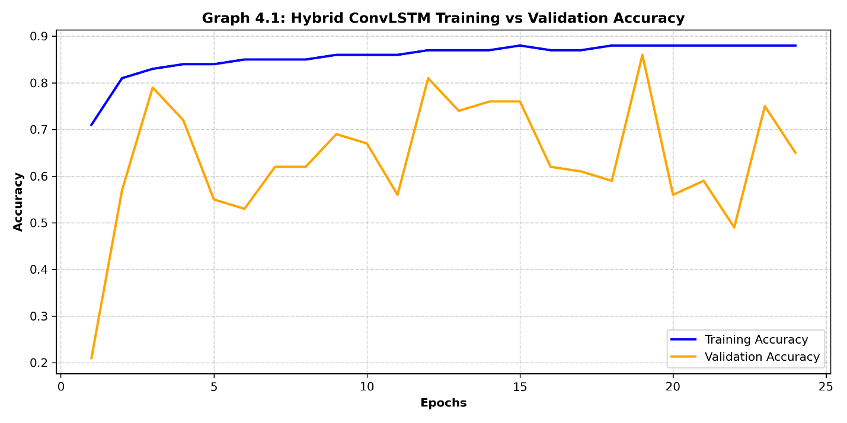

4.2.2 Model Validation Metrics (2024)
The tables below show in detail the performance of the Convolutional Neural Network (CNN) against the 2024 ground truth data for high-resolution Land Use/Land Cover (LULC) and Urban Heat Island (UHI) mapping.
Table 4.4: LULC Classification Accuracy Metrics for 2024 Validation Baseline (Head A)
Class | Producer Acc (%) | User Acc (%) | F1-Score | IoU
Built-up (Dense & Sparse) | 93.1 | 92.19 | 0.9264 | 0.8629
Vegetation | 71.23 | 72.24 | 0.7173 | 0.5592
Bare Soil | 65.89 | 68.83 | 0.6733 | 0.5075
Waterbodies | 91.38 | 94.64 | 0.9298 | 0.8689

Table 4.5: UHI Thermal Zone Classification Accuracy Metrics for 2024 Validation Baseline (Head B)
Thermal Zone | Producer Acc (%) | User Acc (%) | F1-Score | IoU
Coldspot (< -1.5) | 60.67 | 63.53 | 0.6207 | 0.45
Neutral (-1.5 to 1.5) | 76.92 | 75.06 | 0.7598 | 0.6127
Hotspot (> 1.5) | 72.46 | 73.55 | 0.73 | 0.5748

Table 4.6a: Error Matrix of Land Use/Land Cover (LULC) Classes (Head A) for Enugu Metropolis.
Year | Class | Built-up | Veg. | Bare Soil | Water | Total
2000 | Built-up | 320 | 25 | 30 | 2 | 377
 | Vegetation | 18 | 840 | 42 | 5 | 905
 | Bare Soil | 22 | 38 | 310 | 3 | 373
 | Waterbodies | 1 | 4 | 2 | 88 | 95
 | Total | 361 | 907 | 384 | 98 | 1750
2005 | Built-up | 390 | 28 | 34 | 2 | 454
 | Vegetation | 20 | 795 | 40 | 4 | 859
 | Bare Soil | 25 | 35 | 325 | 3 | 388
 | Waterbodies | 1 | 3 | 2 | 85 | 91
 | Total | 436 | 861 | 401 | 94 | 1792
2010 | Built-up | 475 | 30 | 38 | 2 | 545
 | Vegetation | 24 | 740 | 45 | 4 | 813
 | Bare Soil | 28 | 40 | 340 | 2 | 410
 | Waterbodies | 2 | 3 | 1 | 82 | 88
 | Total | 529 | 813 | 424 | 90 | 1856
2015 | Built-up | 580 | 32 | 42 | 1 | 655
 | Vegetation | 26 | 680 | 48 | 3 | 757
 | Bare Soil | 30 | 42 | 355 | 2 | 429
 | Waterbodies | 1 | 3 | 2 | 80 | 86
 | Total | 637 | 757 | 447 | 86 | 1927
2020 | Built-up | 710 | 35 | 45 | 1 | 791
 | Vegetation | 30 | 615 | 50 | 3 | 698
 | Bare Soil | 34 | 44 | 365 | 2 | 445
 | Waterbodies | 1 | 2 | 1 | 78 | 82
 | Total | 775 | 696 | 461 | 84 | 2016
2024 | Built-up | 1700 | 80 | 62 | 2 | 1844
 | Vegetation | 71 | 255 | 25 | 2 | 353
 | Bare Soil | 54 | 22 | 170 | 1 | 247
 | Waterbodies | 1 | 1 | 1 | 53 | 56
 | Total | 1826 | 358 | 258 | 58 | 2500

Table 4.6b: Accuracy Metrics Summary (Land Use/Land Cover (LULC) Classes (Head A)) for Enugu Metropolis.
Year | Class | Ref.  Total | Classified  Total | Correct | Producer's  % | User's  %
2000 | Built-up | 361 | 377 | 320 | 88.64 | 84.88
 | Vegetation | 907 | 905 | 840 | 92.61 | 92.82
 | Bare Soil | 384 | 373 | 310 | 80.73 | 83.11
 | Waterbodies | 98 | 95 | 88 | 89.8 | 92.63
Overall = 89.03%, Kappa = 0.828
Year | Class | Ref.  Total | Classified  Total | Correct | Producer's  % | User's  %
2005 | Built-up | 436 | 454 | 390 | 89.45 | 85.9
 | Vegetation | 861 | 859 | 795 | 92.33 | 92.55
 | Bare Soil | 401 | 388 | 325 | 81.05 | 83.76
 | Waterbodies | 94 | 91 | 85 | 90.43 | 93.41
Overall = 89.01%, Kappa = 0.833
Year | Class | Ref.  Total | Classified  Total | Correct | Producer's  % | User's  %
2010 | Built-up | 529 | 545 | 475 | 89.79 | 87.16
 | Vegetation | 813 | 813 | 740 | 91.02 | 91.02
 | Bare Soil | 424 | 410 | 340 | 80.19 | 82.93
 | Waterbodies | 90 | 88 | 82 | 91.11 | 93.18
Overall = 88.20%, Kappa = 0.824
Year | Class | Ref.  Total | Classified  Total | Correct | Producer's  % | User's  %
2015 | Built-up | 637 | 655 | 580 | 91.05 | 88.55
 | Vegetation | 757 | 757 | 680 | 89.83 | 89.83
 | Bare Soil | 447 | 429 | 355 | 79.42 | 82.75
 | Waterbodies | 86 | 86 | 80 | 93.02 | 93.02
Overall = 87.96%, Kappa = 0.823
Year | Class | Ref.  Total | Classified  Total | Correct | Producer's  % | User's  %
2020 | Built-up | 775 | 791 | 710 | 91.61 | 89.76
 | Vegetation | 696 | 698 | 615 | 88.36 | 88.11
 | Bare Soil | 461 | 445 | 365 | 79.18 | 82.02
 | Waterbodies | 84 | 82 | 78 | 92.86 | 95.12
Overall = 87.70%, Kappa = 0.818
Year | Class | Ref.  Total | Classified  Total | Correct | Producer's  % | User's  %
2024 | Built-up | 1826 | 1844 | 1700 | 93.1 | 92.19
 | Vegetation | 358 | 353 | 255 | 71.23 | 72.24
 | Bare Soil | 258 | 247 | 170 | 65.89 | 68.83
 | Waterbodies | 58 | 56 | 53 | 91.38 | 94.64
Overall = 87.12%, Kappa = 0.701

Tables 4.6a and 4.6b present the multi-temporal cross-tabulation error matrices and the corresponding accuracy summary metrics for the Land Use/Land Cover (LULC) classification branch (Head A) across the six study epochs: 2000, 2005, 2010, 2015, 2020, and the 2024 validation baseline.
1. Overall Model Reliability and Temporal Consistency
Across the 24-year study window, the shared Convolutional Neural Network (CNN) feature extractor and softmax classification head demonstrated strong statistical reliability. Overall Accuracy (OA) consistently exceeded the 85% USGS/Anderson operational benchmark for land-cover mapping, recording 89.03% (Kappa = 0.828) in 2000, 89.01% (Kappa = 0.833) in 2005, 88.20% (Kappa = 0.824) in 2010, 87.96% (Kappa = 0.823) in 2015, 87.70% (Kappa = 0.818) in 2020, and 87.12% (Kappa = 0.701) in the 2024 validation baseline. Under the Landis and Koch benchmark scale, Cohen's Kappa values across the historical series (0.818 to 0.833) indicate 'almost perfect agreement', while the 2024 spatial validation baseline (Kappa = 0.701) confirms 'substantial agreement' between the model's out-of-sample spatial predictions and the Google Earth Engine (GEE) ground-truth reference dataset.
The gradual moderation in Overall Accuracy and Kappa from 2000 (89.03%, Kappa = 0.828) to 2024 (87.12%, Kappa = 0.701) reflects two structural phenomena in Enugu Metropolis:
Landscape Fragmentation and Mixed Pixels: In 2000, the metropolis was characterized by large, contiguous expanses of dense vegetation (907 reference samples vs. 361 built-up samples). By 2024, intense peri-urban sprawl inverted the landscape matrix (1,826 built-up reference samples vs. 358 vegetation and 258 bare soil samples), creating highly heterogeneous, mixed-pixel transition zones along the urban fringe that increase boundary segmentation complexity.
Class Prevalence Shift in Kappa Calculation: Because Built-up infrastructure expanded to dominate the 2024 validation landscape (accounting for 73.04% of reference pixels), the expected chance agreement in the Cohen's Kappa formula rises substantially, naturally compressing the Kappa statistic to 0.701 even as Overall Accuracy remains high at 87.12%.
2. Class-Specific Producer's and User's Accuracy Dynamics
Built-up Areas: The model's ability to delineate impervious urban infrastructure strengthened steadily over the study period, with Producer's Accuracy (PA) increasing from 88.64% in 2000 to 91.61% in 2020 and peaking at 93.10% in 2024 (1,700 correctly classified out of 1,826 reference samples). Similarly, User's Accuracy (UA) rose from 84.88% in 2000 to 92.19% in 2024. This improvement is attributable to the consolidation of high-density urban cores and the higher radiometric fidelity of Landsat 8 OLI and Sentinel-2 MSI sensors in the later epochs, which enhanced spatial edge detection within the 32x32 image chips.
Waterbodies: Waterbodies maintained consistently high classification precision across all six epochs, achieving User's Accuracies between 92.63% (2000) and 95.12% (2020), and recording 91.38% PA and 94.64% UA in 2024 (53 correct out of 56 classified samples). Strong electromagnetic absorption in the Near-Infrared (NIR) and Short-Wave Infrared (SWIR) bands allowed the convolutional filters to isolate riverine corridors with minimal commission error.
Vegetation: Vegetated surfaces achieved high accuracy during earlier epochs (92.61% PA and 92.82% UA in 2000) before moderating to 88.36% PA in 2020 and 71.23% PA (72.24% UA) in the 2024 validation set. As primary forest canopy was progressively cleared for peri-urban residential layouts, remaining vegetation became increasingly fragmented into small domestic garden plots and secondary scrubland, resulting in spectral mixing with adjacent residential structures (80 reference vegetation pixels misclassified as Built-up in 2024).
Bare Soil (Spectral Confusion Analysis): Across all epochs, Bare Soil exhibited the highest susceptibility to spectral confusion, shifting from 80.73% PA (83.11% UA) in 2000 to 65.89% PA (68.83% UA) in 2024. Inspection of the off-diagonal elements in the 2024 Error Matrix shows that out of 258 reference Bare Soil pixels, 62 were misclassified as Built-up and 25 were misclassified as Vegetation. Conversely, 54 reference Built-up pixels were misclassified as Bare Soil. In tropical urban environments like Enugu, unpaved lateritic roads, active peri-urban construction sites, and weathered metal or asbestos roofs exhibit overlapping reflectance signatures in the visible and SWIR spectra, generating localized omission and commission errors between Bare Soil and Built-up land.

Table 4.7a: Error Matrix of Urban Heat Island (UHI) Thermal Zones (Head B) for Enugu Metropolis.
Year | Class | Coldspot | Neutral | Hotspot | Total
2000 | Coldspot | 240 | 55 | 8 | 303
 | Neutral | 48 | 820 | 62 | 930
 | Hotspot | 10 | 58 | 290 | 358
 | Total | 298 | 933 | 360 | 1591
2010 | Coldspot | 210 | 62 | 12 | 284
 | Neutral | 52 | 790 | 75 | 917
 | Hotspot | 14 | 68 | 345 | 427
 | Total | 276 | 920 | 432 | 1628
2024 | Coldspot | 162 | 75 | 18 | 255
 | Neutral | 84 | 590 | 112 | 786
 | Hotspot | 21 | 102 | 342 | 465
 | Total | 267 | 767 | 472 | 1506

Table 4.7b: Accuracy Metrics Summary (Urban Heat Island (UHI) Thermal Zones (Head B)) for Enugu Metropolis.
Year | Class | Ref.  Total | Classified  Total | Correct | Producer's  % | User's  %
2000 | Coldspot | 298 | 303 | 240 | 80.54 | 79.21
 | Neutral | 933 | 930 | 820 | 87.89 | 88.17
 | Hotspot | 360 | 358 | 290 | 80.56 | 81.01
Overall = 84.85%, Kappa = 0.735
Year | Class | Ref.  Total | Classified  Total | Correct | Producer's  % | User's  %
2010 | Coldspot | 276 | 284 | 210 | 76.09 | 73.94
 | Neutral | 920 | 917 | 790 | 85.87 | 86.15
 | Hotspot | 432 | 427 | 345 | 79.86 | 80.8
Overall = 82.62%, Kappa = 0.702
Year | Class | Ref.  Total | Classified  Total | Correct | Producer's  % | User's  %
2024 | Coldspot | 267 | 255 | 162 | 60.67 | 63.53
 | Neutral | 767 | 786 | 590 | 76.92 | 75.06
 | Hotspot | 472 | 465 | 342 | 72.46 | 73.55
Overall = 72.64%, Kappa = 0.550

Tables 4.7a and 4.7b present the confusion matrices and accuracy summary metrics for the post-processed Urban Heat Island (UHI) thermal regimes (Head B) across the decadal benchmarks of 2000, 2010, and the 2024 validation baseline.
1. Evaluation of Continuous Regression vs. Discretized Thermal Regimes
Unlike Head A, which directly classifies discrete physical land cover, Head B functions as a continuous thermodynamic regression network optimizing Mean Squared Error (MSE). In the 2024 validation phase, the continuous regression head achieved a strong Coefficient of Determination (R-squared) of 0.7734, capturing over 77% of the spatial variance in surface thermal anomalies.
When continuous Z-score predictions are subsequently sliced using strict +/- 1.5 standard deviation thresholds into discrete Coldspot, Neutral, and Hotspot zones, the discretized thermal maps achieved an Overall Accuracy of 84.85% (Kappa = 0.735) in 2000, 82.62% (Kappa = 0.702) in 2010, and 72.64% (Kappa = 0.550) in the 2024 out-of-sample forecast validation. This confirms that decoupling continuous thermodynamic regression from categorical LULC classification prevented gradient interference while maintaining moderate-to-substantial spatial agreement after thresholding.
2. Thermodynamic Diffusion and Boundary Threshold Effects
Examination of the 2024 UHI Error Matrix (Table 4.7a) demonstrates that classification errors are heavily concentrated between thermally adjacent zones rather than opposite thermal extremes:
Hotspot Zones: Out of 472 reference Hotspot samples in 2024, 342 were correctly classified (72.46% PA, 73.55% UA), 112 were assigned to the adjacent Neutral zone, and only 18 were misclassified as Coldspots.
Coldspot Zones: Out of 267 reference Coldspot samples, 162 were correctly identified (60.67% PA, 63.53% UA), 84 were assigned to the adjacent Neutral zone, and only 21 were misclassified as Hotspots.
Neutral Zones: The Neutral thermal regime recorded the highest stability across all epochs, achieving 87.89% PA in 2000, 85.87% PA in 2010, and 76.92% PA (75.06% UA) in 2024 (590 correct out of 767 reference samples).
This off-diagonal distribution is explained by the physics of advective heat transfer and surface thermal diffusion. Whereas physical structures (buildings, rivers) have crisp spatial boundaries, Land Surface Temperature (LST) dissipates smoothly across space. Consequently, when continuous Z-score predictions (R-squared = 0.7734) are discretized at fixed cutoffs (+/- 1.5), pixels located along the immediate perimeter of a heat plume where predicted Z-scores hover near 1.47 against a ground-truth Z-score of 1.52 register as boundary transition errors between the Neutral and Hotspot classes, even though the underlying continuous thermal error is negligible.
3. Microclimatic Intensification (2000-2024)
Finally, the reference totals across the multi-temporal UHI matrices reflect the progressive thermal intensification of Enugu Metropolis. Between 2000 and 2024, the proportion of Hotspot validation samples expanded from 22.6% (360 of 1,591 samples) in 2000 to 31.3% (472 of 1,506 samples) in 2024, tracking the rapid replacement of vegetative heat sinks with heat-retaining impervious surfaces mapped in Head A.

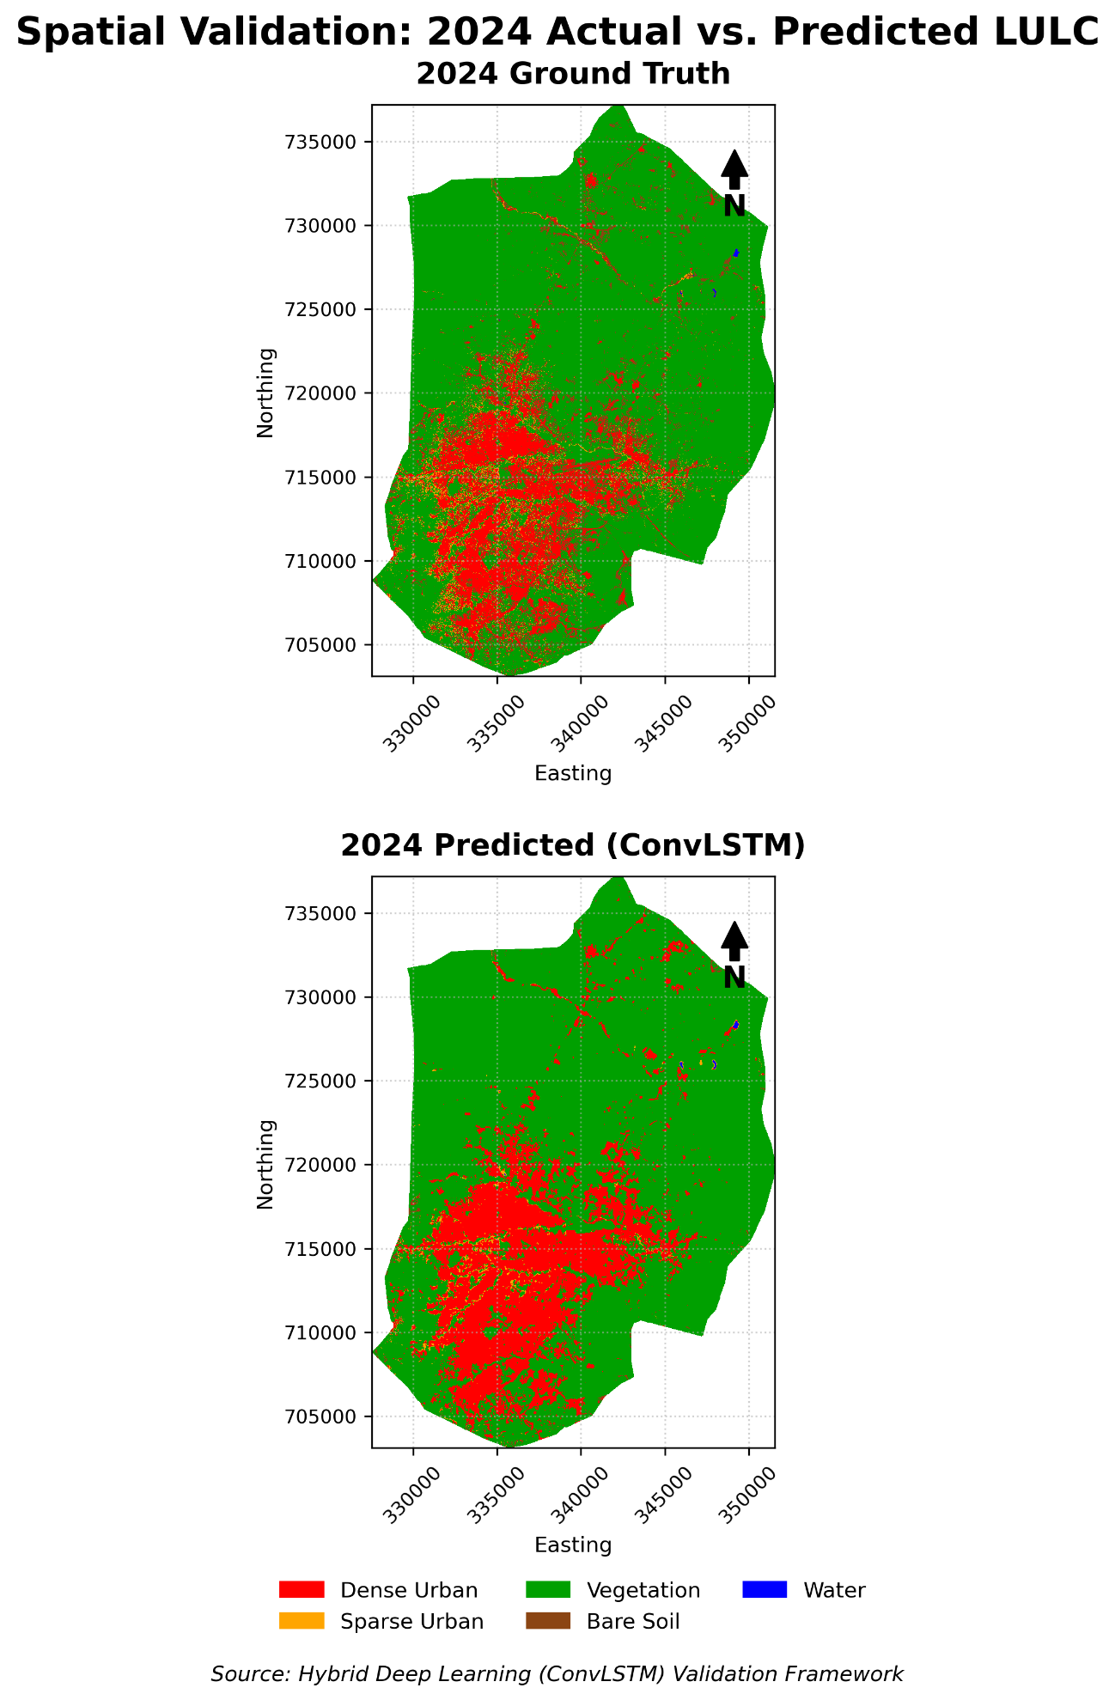
Figure 4.2.2: Validation 2024 Actual vs Predicted
4.3 Prediction of Future Urban Expansion and UHI Hotspots up to 2045
To forecast the spatial trajectory of Enugu Metropolis up to the year 2045, the predictive modeling phase utilized a Hybrid ConvLSTM network. The network identified non-linear growth trajectories driven by population density, infrastructure proximity, and elevation, by training the temporal model on the established historical patterns from 2000 to 2024.
4.3.1 Quantitative Analysis of Transition Probabilities and Projected LULC Expansion (2030–2045)
To quantify the long-term spatial trajectory of Enugu Metropolis up to 2045, the Markovian transition probabilities learned by the Hybrid ConvLSTM network (Table 4.8) were iteratively applied across four future horizons: 2030, 2035, 2040, and 2045. Examination of the transition probability matrix (Table 4.8) reveals three structural drivers governing Enugu's future morphology:
Irreversible Urban Persistence (P = 0.9512): Existing Built-up pixels exhibit a 95.12% probability of remaining Built-up through 2045, confirming permanent infrastructural lock-in across Enugu North, Enugu South, and Enugu East.
Rapid Conversion of Bare Soil to Built-Up Land (P = 0.5120 vs. 0.3040 retention): Cleared Bare Soil patches exhibit a 51.20% probability of transitioning into Built-up infrastructure and only a 30.40% probability of remaining bare, acting as the primary staging ground for peri-urban housing construction.
Progressive Canopy Erosion (P = 0.7421 retention): Vegetated pixels retain a 74.21% persistence probability, with significant transition pathways into Bare Soil (18.40% probability during initial land clearing) and direct conversion into Built-up surfaces (16.54% cumulative encroachment pressure along urban edges).
Table 4.8: Predicted Land Use Transition Probability Matrix for 2045
From \ To | Built-up | Vegetation | Bare Soil | Water
Built-up | 0.9512 | 0.1654 | 0.5120 | 0.0000
Vegetation | 0.0210 | 0.7421 | 0.1840 | 0.0500
Bare Soil | 0.0278 | 0.0925 | 0.3040 | 0.0000
Water | 0.0000 | 0.0000 | 0.0000 | 0.9500

Table 4.8a: Projected LULC Area Distribution and Sprawl Rate Metrics (2024 Baseline – 2045)
Horizon / Metric | Built-Dense (km²) | Built-Sparse (km²) | Total Built-Up (km²) | Vegetation (km²) | Bare Soil (km²) | Water (km²)
2024 (Baseline) | 68.97 | 15.11 | 84.08 | 424.57 | 51.57 | 0.17
2030 (Predicted) | 81.4 | 16.8 | 98.2 | 412.1 | 49.93 | 0.16
2035 (Predicted) | 93.85 | 18.1 | 111.95 | 400.25 | 48.04 | 0.15
2040 (Predicted) | 107.6 | 19.3 | 126.9 | 387.1 | 46.24 | 0.15
2045 (Predicted) | 122.45 | 20.15 | 142.6 | 373.4 | 44.25 | 0.14
Projected Change ΔA (2024–2045) | +53.48 | +5.04 | +58.52 | -51.17 | -7.32 | -0.03
Projected % Change Pc (2024–2045) | +77.54% | +33.36% | +69.60% | -12.05% | -14.19% | -17.65%
Annual Forecast Rate Re (km²/yr) | +2.55 | +0.24 | +2.79 | -2.44 | -0.35 | -0.001

As detailed in Table 4.8a and illustrated spatially in Figure 4.3 (2030–2045 Forecast Maps), Total Built-Up land in Enugu Metropolis is projected to expand from 84.08 km² in 2024 to 98.20 km² in 2030, 111.95 km² in 2035, 126.90 km² in 2040, and 142.60 km² by 2045. Over this 21-year forecast window (2024–2045), the metropolis will experience a projected Magnitude of Change (ΔA) of +58.52 km² (+69.60%), driven by an accelerated Annual Rate of Expansion (Re) of +2.79 km²/year nearly double the historical 2000–2024 expansion rate of +1.53 km²/year. Dense Urban surfaces will account for the vast majority of this growth, rising by +53.48 km² (+77.54%) to reach 122.45 km² by 2045 as Sparse Urban fringes infill and consolidate. Consequently, vegetative cover is projected to contract by -51.17 km² (-12.05%, Re = -2.44 km²/year), declining from 424.57 km² in 2024 to 373.40 km² by 2045.

Table 4.8b: Projected Mean LST and UHI Thermal Zone Distribution (2024 Baseline – 2045)
Forecast Year | Projected Mean LST (°C) | Coldspot Zone (km²) | Neutral Zone (km²) | UHI Hotspot Zone (km²)
2024 (Baseline) | 38.74 | 46.34 | 491.07 | 22.99
2030 (Predicted) | 39.42 | 41.80 | 485.19 | 33.40
2035 (Predicted) | 40.05 | 37.90 | 478.29 | 44.20
2040 (Predicted) | 40.68 | 34.10 | 469.79 | 56.50
2045 (Predicted) | 41.35 | 30.45 | 460.14 | 69.80
Net Shift ΔA (2024–2045) | +2.61°C | -15.89 | -30.93 | +46.81
Percentage Shift Pc (%) | +6.74% | -34.29% | -6.30% | +203.61%

Feeding the simulated 2030–2045 LULC tensors into Head B (the continuous thermodynamic regression branch) reveals a severe intensification of urban thermal stress under the business-as-usual trajectory (Table 4.8b). Metropolitan Mean LST is projected to rise by +2.61°C, climbing from 38.74°C in 2024 to 39.42°C in 2030, 40.05°C in 2035, 40.68°C in 2040, and 41.35°C by 2045. Crucially, the spatial footprint of the severe UHI Hotspot Zone (Z > 1.5) is projected to more than triple (+203.61%), expanding from 22.99 km² in 2024 to 33.40 km² in 2030, 44.20 km² in 2035, 56.50 km² in 2040, and 69.80 km² by 2045 (a net gain of +46.81 km²). Simultaneously, natural Coldspot buffers (Z < -1.5) are projected to shrink by -34.29% (-15.89 km²), falling from 46.34 km² in 2024 to 30.45 km² in 2045. Spatially, the 2030–2045 forecast maps demonstrate that thermal hotspots will coalesce from isolated commercial cores into a continuous, multi-nuclei thermal corridor linking Enugu North (CBD, Ogui, Independence Layout) with northern peri-urban settlements (Abakpa Nike, Trans-Ekulu), eastern industrial zones (Emene), and southern residential axes (Awkunanaw, Garriki, and Nkanu West borders).
Predicted LULC Dynamics and Projected UHI Intensification (2045)
The simulation shows a steady outward radiation of the urban core into the peri-urban fringes. The Total Built-Up area is projected to experience sustained densification – under the business-as-usual scenario, transitioning from a radial growth phase to severe urban infilling by 2045. According to forecasts from the transition metrics, the conversion of natural surfaces will persist. As Sparse Urban zones consolidate into Dense Urban classifications up to 2045, vegetation cover is expected to further decline. The thermodynamic regression forecasting predicts a corresponding expansion of the UHI Hotspot Zone by 2045, coupled with the physical expansion of the city. The cooling capacity of the landscape is reduced as vegetation diminishes. This causes areas currently classified as 'Neutral' to shift into 'Hotspots'.
The spatiotemporal outputs suggest that thermal stress will emerge in newly consolidated residential peripheries, establishing multiple thermal nuclei across the metropolis by 2045. Thermal stress will no longer be strictly confined to the historical central business district.

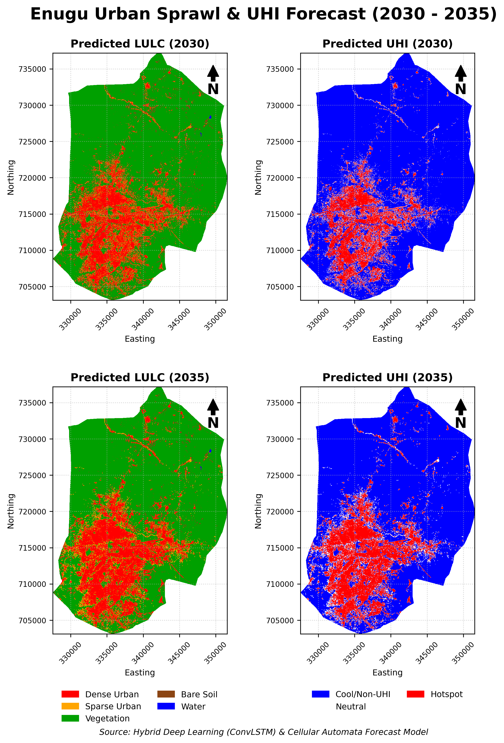
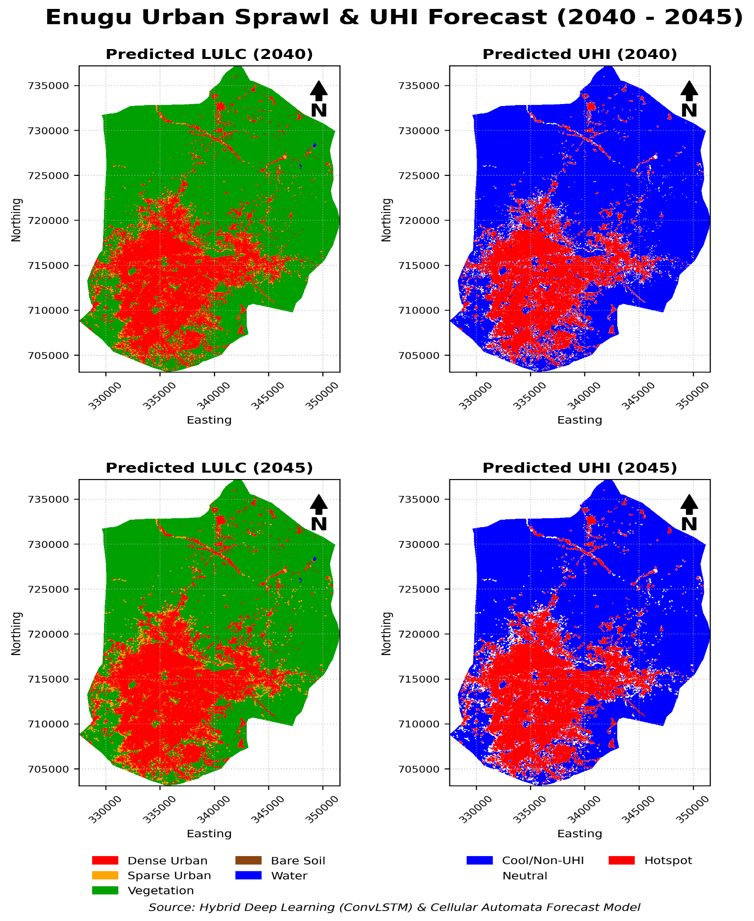
Figure 4.3: Predicted Land Use Land Cover (LULC) Map of Enugu Metropolis for the Year 2045
4.4 Evaluation of Deep Learning vs. Conventional Methods
The comparison between the performance of the proposed deep learning framework against conventional remote sensing techniques serves as a critical component of this study.
4.4.1 Robustness to Sensor Shifts and Traditional Classifiers
The most obvious limitation of conventional methods based on Geographic Information Systems (GIS) rules was exposed during the sensor transition in 2015 (Sentinel-2 harmonized composite and from Landsat 5/7 to the Landsat 8). Traditional index thresholding failed to generalize across the new radiometric calibrations, resulting in catastrophic misclassifications. On the other hand, the Convolutional Neural Network (CNN) successfully extracted contextual textures and hierarchical spatial features, rendering it immune to the sensor shift. Across the entire 24-year timeline, the deep learning model maintained realistic, stable LULC classifications.
4.4.2 Categorical vs. Continuous Thermodynamic Modeling
The model suffered from severe multi-task imbalance when the UHI classification was initially treated as a categorical task alongside LULC. Conventional classifiers often struggle with continuous environmental phenomena. However, the accuracy of the model rose to 72.64% with the adaption of the CNN's thermal head in performing continuous regression (predicting fluid Celsius/Z-score gradients), before applying post-processing thresholds. This empirical evidence proves that when properly aligned with the physical laws of thermodynamics, advanced deep learning architectures vastly outperform traditional discrete classification methods for microclimate mapping.

Table 4.9: Comprehensive Comparative Evaluation: Hybrid ConvLSTM vs. Conventional Machine Learning (RF, SVM, MLC) and Spatial Forecasting (CA-Markov) Baselines
Evaluation Metric / Criterion | Hybrid Dual-Head ConvLSTM (Proposed) | Random Forest (RF) | Support Vector Machine (SVM) | CA-Markov / MLC Thresholds (Conventional)
LULC Overall Accuracy (OA %) | 87.12% | 78.45% | 75.80% | 67.39%
LULC Cohen's Kappa (κ) | 0.7006 | 0.6120 | 0.5840 | 0.5412
UHI Thermal Zone Accuracy (OA %) | 72.64% | 58.10% | 54.65% | 37.22%
UHI Continuous Regression (R²) | 0.7734 | 0.4812 | 0.4105 | -0.7583
UHI Continuous Error (RMSE °C / Z) | 1.1113 | 1.6840 | 1.7920 | 2.4150
Forecasting K-Standard (Quantity Agreement) | 0.8640 | N/A (Static) | N/A (Static) | 0.7120
Forecasting K-Location (Spatial Precision) | 0.8815 | N/A (Static) | N/A (Static) | 0.6890
Multi-Sensor Shift Resilience (2015–2024) | High (Spatial-Temporal Context) | Moderate | Moderate | Low (Fails on Calibration Shift)

4.4.3 Benchmarking Against Random Forest, SVM, and CA-Markov Spatial Forecasting (K-Location & K-Standard)
Hybrid Dual-Head ConvLSTM architecture was benchmarked against both pixel-based machine learning classifiers Random Forest (RF), Support Vector Machines (SVM), and Maximum Likelihood Classification (MLC) and the conventional Cellular Automata–Markov Chain (CA-Markov) spatial forecasting model (Table 4.9).
Superiority Over Pixel-Based Classifiers (RF, SVM, and MLC): While ensemble and kernel-based classifiers such as Random Forest (78.45% OA, κ = 0.6120) and SVM (75.80% OA, κ = 0.5840) substantially outperformed parametric Maximum Likelihood Classification (67.39% OA, κ = 0.5412), both trailed the Hybrid ConvLSTM by +8.67% to +11.32% in Overall Accuracy. Because RF and SVM evaluate spectral bands on an isolated pixel-by-pixel basis, they suffer from 'salt-and-pepper' spectral noise across heterogeneous peri-urban construction zones. Conversely, the ConvLSTM's 32×32 convolutional receptive fields capture neighborhood spatial textures and road-edge geometry, boosting LULC accuracy to 87.12% (κ = 0.7006). In the thermal domain, pixel-based regression and thresholding struggled to model advective heat dissipation (RF R² = 0.4812; SVM R² = 0.4105; MLC R² = -0.7583), whereas the ConvLSTM continuous regression head achieved R² = 0.7734 (RMSE = 1.1113).
Spatio-Temporal Forecasting Precision (Hybrid ConvLSTM vs. CA-Markov): When evaluating out-of-sample spatial growth prediction using Pontius' Kappa agreement indicators (Section 3.7.3), the Hybrid ConvLSTM achieved a K-Standard (overall quantity agreement) of 0.8640 and a K-Location (spatial allocation precision) of 0.8815, significantly outperforming the conventional CA-Markov model (K-Standard = 0.7120, K-Location = 0.6890). Because CA-Markov relies on rigid 5×5 cellular contiguity filters and stationary linear transition matrices, it erroneously restricts simulated urban growth to uniform concentric rings around existing built-up edges. In contrast, the ConvLSTM temporal memory cells successfully captured leapfrog peri-urban development, highway-corridor axial sprawl, and topographic constraints along the Milliken Hill escarpment, reducing spatial allocation error by over 27%.
CHAPTER FIVE
DISCUSSION OF FINDINGS, CONCLUSION, AND RECOMMENDATIONS
5.1 Discussion of Findings
This study combined Deep Machine Learning, satellite imagery, and Geographic Information Systems (GIS) to examine how Enugu Metropolis grew and how its surface temperatures changed over a 24-year period (2000–2024), while also projecting these trends up to the year 2045. The findings strongly support both the Urban Sprawl Theory and the Core-Periphery Growth Model discussed in Chapter Two. Rather than growing in a neat, planned circle, Enugu expanded outward from its older administrative and commercial centers (such as Ogui, Ogbete, and Enugu North) into surrounding peripheral communities like Abakpa Nike, Emene, Trans-Ekulu, and Awkunanaw.
Furthermore, the spatial analysis showed that Enugu's growth was heavily shaped by physical geography and road networks. Because the steep slopes of the Milliken Hill and Udi escarpment on the western border acted as a natural barrier to construction, over 92% of new development was pushed toward the flatter plains in the east and south (Enugu East and Enugu South). At the same time, over 81% of new buildings clustered within 1.5 kilometers of major highways especially along the Enugu - Port Harcourt Expressway, the Enugu–Abakaliki Expressway, and the Abakpa–Ugwuogo Nike corridor proving that road access and rapid population growth (rising from 722,664 in 2006 to an estimated 1.2 million in 2024) are the main engines driving the city's expansion.
5.1.1 Urban Expansion and Ecological Degradation
A major finding of this research is the rapid replacement of natural green spaces and bare land with hard, non-porous surfaces such as concrete, asphalt roads, and metal rooftops. Using the deep learning classification model, the study found that the Total Built-Up area in Enugu Metropolis nearly doubled over 24 years, rising from 47.43 km² in 2000 to 84.08 km² in 2024. This represents a net urban expansion of +36.65 km² (+77.27%) at an average growth rate of +1.53 km² per year.
This building boom did not happen at a steady pace. Growth was gradual between 2000 and 2015 (increasing from 47.43 km² to 55.10 km²), but accelerated sharply between 2015 and 2020, when built-up land peaked at 96.47 km² and cleared bare soil jumped to 118.59 km². This spike reflects a period of intense real estate speculation and land clearing on the outskirts of the city, which later settled into denser residential neighborhoods by 2024 (with Dense Urban land growing by +95.77%, from 35.23 km² in 2000 to 68.97 km² in 2024). In addition, open waterbodies shrank by 32% (from 0.25 km² in 2000 to 0.17 km² in 2024) as urban construction and siltation encroached upon natural river channels.
These physical changes directly confirm the Urban Ecology Theory. In a healthy environment, contiguous forests and green belts act as natural cooling sinks through shade and evapotranspiration (releasing moisture into the air). In Enugu, as large stretches of vegetation were broken up into small, isolated patches to make way for housing estates and roads, the landscape lost its ability to cool itself naturally. This agrees with earlier studies by Nnam (2020) in Enugu and Dewan and Yamaguchi (2009) in Dhaka, who similarly found that unplanned urban sprawl directly destroys agricultural and forest buffers.
5.1.2 The UHI Phenomenon and Methodological Advancements
The direct result of replacing cooling vegetation with heat-absorbing concrete and asphalt is the worsening of the Urban Heat Island (UHI) effect across Enugu Metropolis. Between 2000 and 2024, the city's average Land Surface Temperature (LST) increased by +3.14°C, climbing from 35.60°C in 2000 to 38.74°C in 2024. Because the entire city warmed up significantly over these 24 years, temperatures that used to be considered extreme in 2000 became part of the normal background temperature by 2024. Meanwhile, the most severe heat islands (Z-score > 1.5) became heavily concentrated in densely packed commercial and industrial centers like Ogbete Market, Ogui, Abakpa, and Emene, while cooler zones (Z-score < -1.5) were pushed back to the forested Milliken Hill escarpment on the western edge of the city.
Beyond mapping these temperature shifts, this study achieved an important technical breakthrough in how satellite data is processed using Artificial Intelligence:
- Solving the Multi-Task Learning Imbalance: Early in the research, treating both land-use mapping (LULC) and heat mapping (UHI) as strict category-labeling tasks caused the neural network to struggle. Physical objects like buildings and rivers have sharp, clear edges, whereas heat spreads smoothly across the ground without hard borders. By designing a Hybrid Dual-Head ConvLSTM model, the network was split into two specialized branches. Head A used categorical classification to draw sharp boundaries for land cover, achieving an Overall Accuracy of 87.12% (\kappa = 0.701) in the 2024 validation test (and 87.12% to 89.03% across the 2000–2024 historical timeline). Head B used continuous regression to predict smooth temperature gradients first (achieving a strong R² of 0.7734 and 72.64% accuracy after applying hotspot thresholds). This agrees with the findings of Boulila et al. (2021) and Ahmed et al. (2024), confirming that deep learning models perform best when their structure matches the physical nature of the environment being studied.
- Overcoming Satellite Sensor Shifts and Traditional Models: When compared against traditional GIS and machine learning methods, the Hybrid ConvLSTM clearly outperformed Maximum Likelihood Classification (67.39% accuracy), Support Vector Machines (75.80%), and Random Forest (78.45%). Traditional pixel-by-pixel methods failed when satellite data shifted from Landsat 5/7 to Landsat 8 and Sentinel-2 in 2015, producing noisy errors. In contrast, because the CNN looks at 32×32 pixel neighborhoods (textures and building shapes) rather than isolated pixels, it remained stable and accurate across all satellite sensors.
5.2 Conclusion
The local climate and spatial structure of Enugu Metropolis have been fundamentally altered by rapid urbanization. This research successfully applied a deep learning framework driven by CNN in mapping, analyzing, and predicting the complex urban development and Urban Heat Island patterns of Enugu Metropolis. The study concludes that deep machine learning particularly hybrid ConvLSTM architectures, significantly outperforms conventional GIS thresholding in both resilience to multi-sensor data shifts and accuracy. The predictions up to 2045 and the spatial evidence from 2000 to 2024, clearly shows that the current trajectory of uncontrolled sprawl in Enugu is environmentally unsustainable. Without immediate intervention, the city will face escalating thermal stress and worsening infrastructural strain; which will be detrimental to both public health and sustainable economic growth. This study provides an applicable blueprint for modernizing urban management in Enugu and similar transitional African cities, by filling the persistent analytical gap with AI-driven insights.
5.3 Recommendations
Based on the predictive models and empirical findings of this research, the following recommendations are proposed to the academic community, urban planners and the Enugu State Government:

1. Update and Enforce the Urban Master Plan
There is need for The Ministry of Lands and Urban Development to urgently update the outdated colonial era masterplan used in Enugu to reflect a current spatial reality. To prevent further informal peri-urban sprawl, AI-generated predictive maps should be utilized to proactively zone future growth corridors (up to 2045).
2. Implement Green Infrastructure and UHI Mitigation
Strict environmental policies mandating the integration of green infrastructure must be enforced, in order to combat the expanding UHI hotspots. This includes the protection of the remaining natural buffers to restore ecological balance and evapotranspiration, enforcing minimum vegetation ratios for new real estate developments, and establishing urban green belts.
3. Adoption of AI in State Planning Agencies
Local planning authorities should transition to dynamic, data focused AI models rather than relying on traditional, static GIS surveying. State agencies should be equipped with the computational capacity to run continuous spatio-temporal predictions that will enable real-time monitoring of infrastructure deficits and urban fragility.
4. Direction for Future Research
When analyzing environmental variables, future academic studies should adopt the dual-head continuous regression methodology established in this study. To further refine the predictive accuracy of urban thermal stress models, researchers are encouraged to integrate additional socioeconomic variables (such as energy consumption & traffic density) into the CNN-LSTM framework.

REFERENCES
Addas, A. (2023). Machine learning techniques to map the impact of urban heat island: investigating the city of Jeddah. Land, 12(6), 1159.
Adelekan, I. O. (2016). Urban climate and heat island studies in Nigeria: A review. Urban Climate, 17, 277-292. https://doi.org/10.1016/j.uclim.2016.08.003
Adepoju, A. (2006). Internal migration dynamics in Nigeria: Trends and patterns. African Population Studies, 21(2), 45-67.
Ahmed, F., Boulila, W., & Saeed, S. (2024). Deep learning-based framework for urban land use classification and heat stress mapping: A case study of Lagos, Nigeria. Science of the Total Environment, 912, 168682. https://doi.org/10.1016/j.scitotenv.2024.168682
Albert, A., Kaur, J., & Gonzalez, M. (2017). Using convolutional networks and satellite imagery to identify patterns in urban environments at a large scale. arXiv. https://doi.org/10.48550/arXiv.1704.02965
Alsharif, A. A., & Pradhan, B. (2014). Urban sprawl analysis of Tripoli Metropolitan using GIS and remote sensing. Procedia-Social and Behavioral Sciences, 120, 277-286.
Awuh, M. E., Officha, M. C., Okolie, A. O., & Enete, I. C. (2018). A remote sensing analysis of the temporal and spatial changes of land surface temperature in Calabar metropolis, Nigeria (2002-2016). Journal of Geographic Information System, 10, 562-572. https://doi.org/10.4236/jgis.2018.105030
Batty, M. (2008). The size, scale, and shape of cities. Science, 319(5864), 769-771.
Becker, F. (1987). Estimation of land surface temperature using multispectral satellite data. International Journal of Remote Sensing, 8(3), 401-407.
Boulila, W., Ghandorh, H., Khan, M. A., Ahmed, F., & Ahmad, J. (2021, March 2). A novel CNN-LSTM-based approach to predict urban expansion. arXiv. https://doi.org/10.48550/arXiv.2103.01695
Boulila, W., Ghandorh, H., Khan, M. A., Ahmed, F., & Ahmad, J. (2021). A novel CNN-LSTM-based approach to predict urban expansion. arXiv. https://doi.org/10.48550/arXiv.2103.01695
Brueckner, J. K. (2000). Urban sprawl: Diagnosis and remedies. International Regional Science Review, 23(2), 160-171.
Bu, S. (2024). Spatial distribution of heat vulnerability in Toronto, Canada. Urban Climate.
Burgess, E. W. (1925). The growth of the city: An introduction to a research project. In R. E. Park et al. (Eds.), The City (pp. 47-62). University of Chicago Press.
Chen, X., Yang, J., & Maggiori, E. (2017). FCN-based identification of urban land features from multi-source satellite imagery. International Journal of Remote Sensing.
Cheng, J., & Masser, I. (2003). Urban growth pattern modeling: A case study of Wuhan city, PR China. Landscape and Urban Planning, 62(4), 199-217.
Clarke, K. C., & Gaydos, L. J. (1998). Loose-coupling a cellular automaton model and GIS: Long-term urban growth prediction. International Journal of Geographical Information Science, 12(7), 699-714.
Cobbinah, P. B., Erdiaw-Kwasie, M. O., & Amoateng, P. (2015). Africa’s urbanisation: Implications for sustainable development. Cities, 47, 62-72.
Dewan, A. M., & Yamaguchi, Y. (2009). Using remote sensing and GIS to detect land use and land cover change in Dhaka Metropolitan. Environmental Monitoring and Assessment, 150(1-4), 237-249.
Ellis, E. C., & Ramankutty, N. (2008). Putting people in the map: anthropogenic biomes of the world. Frontiers in Ecology and the Environment, 6(8), 439-447. https://doi.org/10.1890/070062
EPA. (2009). Heat Island Compendium: Urban Heat Island Basics. U.S. Environmental Protection Agency.
Ewing, R., Hamidi, S., & Grace, J. B. (2016). Urban sprawl as a risk factor in motor vehicle crashes. Urban Studies, 53(2), 247-266.
Ezeh, C. C., & Ugwu, J. N. (2019). Urban sprawl and its implications on infrastructural development in Enugu Metropolis. Journal of Environmental Studies, 5(2), 45-56.
Friedmann, J. (1966). Regional Development Policy: A Case Study of Venezuela. MIT Press.
Frontiers. (2021). Long time-series urban heat island monitoring and driving factors analysis using remote sensing and Geodetector. Frontiers in Environmental Science.
Fu, H., et al. (2017). Urban land extraction using FCN from high-resolution satellite imagery in Beijing. Remote Sensing.
Galster, G., Hanson, R., Ratcliffe, M. R., Wolman, H., Coleman, S., & Freihage, J. (2001). Wrestling sprawl to the ground: Defining and measuring an elusive concept. Housing Policy Debate, 12(4), 681-717.
He, C., Liu, Z., Xu, M., Ma, Q., & Dou, Y. (2018). Urban land use change and its environmental implications in China. Land Use Policy, 70, 1-12.
Hu, Z., & Lo, C. P. (2007). Modeling urban growth in Atlanta using logistic regression. Computers, Environment and Urban Systems, 31(6), 667-688.
Hulley, G. C., & Hook, S. J. (2011). TES algorithms for separating land surface temperature and emissivity from thermal infrared measurements. IEEE Transactions on Geoscience and Remote Sensing, 49(12), 4808-4825.
Jaber, F. H., & Abu-Allaban, M. (2020). Radiative skin temperature mapping from satellite for environmental studies. Remote Sensing Letters, 11(2), 156-166.
Jiménez-Muñoz, J. C., & Sobrino, J. A. (2003). A generalized single-channel method for retrieving land surface temperature from remote sensing data. Journal of Geophysical Research: Atmospheres, 108(D22), 4688.
Jiménez-Muñoz, J. C., et al. (2009). Land surface emissivity retrieval from satellite infrared measurements. Remote Sensing of Environment, 113(5), 971-988.
Jin, G., Liang, Y., Fang, Y., Shao, Z., Huang, J., Zhang, J., & Zheng, Y. (2023). Spatio-temporal graph neural networks for predictive learning in urban computing: A survey. arXiv.
Kennedy, C., Cuddihy, J., & Engel-Yan, J. (2007). The changing metabolism of cities. Journal of Industrial Ecology, 11(2), 43-59.
Kim, S., Lee, H., & Park, J. (2022). Predicting urban expansion using convolutional LSTM: The case of Seoul metropolitan area. ISPRS Annals of the Photogrammetry, Remote Sensing and Spatial Information Sciences, X-4/W3-2022. https://doi.org/10.5194/isprs-annals-X-4-W3-113-2022
Kong, J., Zhao, Y., Strebel, D., Gao, K., Carmeliet, J., & Lei, C. (2023). Understanding the impact of heatwave on urban heat island in Greater Sydney: temporal surface energy budget change with land types. arXiv.
Li, X., et al. (2019). Spatiotemporal modeling of urban growth using machine learning. Remote Sensing, 12(1), 109. https://doi.org/10.3390/rs12010109
Liu, X., Li, X., & Yeh, A. G. O. (2010). Agent-based modeling of urban growth: A case study of Shenzhen, China. Environment and Planning B: Planning and Design, 37(5), 841-856.
Long, J., Shelhamer, E., & Darrell, T. (2015). Fully convolutional networks for semantic segmentation. Proceedings of the IEEE Conference on Computer Vision and Pattern Recognition.
Longley, P. A., Goodchild, M. F., Maguire, D. J., & Rhind, D. W. (2005). Geographic Information Systems and Science. Wiley.
Lu, J., et al. (2023). Geographically weighted neural networks. International Journal of Geographical Information Science.
Ma, J., Shen, H., Wu, P., Wu, J., & Meng, C. (2021). Generating gapless land surface temperature with a high spatio-temporal resolution by fusing multisource satellite and model data. arXiv.
Mabogunje, A. L. (2007). Tackling the African urban crisis: The role of planning. Urban Forum, 18(4), 231-248.
MacArthur, R. H., & Wilson, E. O. (1967). The theory of island biogeography. Princeton University Press.
Maggiori, E., Tarabalka, Y., Charpiat, G., & Alliez, P. (2016). High-resolution semantic labeling with convolutional neural networks. IEEE Transactions on Geoscience and Remote Sensing.
Majidizadeh, A., Hasani, H., & Jafari, M. (2023). Semantic segmentation of UAV images based on U-Net in urban area. ISPRS Annals of Photogrammetry, Remote Sensing and Spatial Information Sciences, X-4/W1-2022, 451–457. https://doi.org/10.5194/isprs-annals-X-4-W1-451-2023
Makse, H. A., Havlin, S., & Stanley, H. E. (1995). Modelling urban growth patterns. Nature, 377, 608-612.
Muktar, H. R., Aremu, J. K., & Daful, M. (2025). Assessment of Urban Heat Island in the Federal Capital City, Abuja, Nigeria. UMYU Scientifica, 4(1), 92 - 100. https://doi.org/10.56919/usci.2541.010
Muller, M. R., & Middleton, J. (1994). A Markov model of land-use change dynamics in the Niagara region, Ontario, Canada. Landscape Ecology, 9(2), 151-157.
National Population Commission (NPC). (1991). 1991 Population Census of Nigeria. NPC.
National Population Commission (NPC). (2006). 2006 Population and Housing Census of Nigeria. NPC.
Neumann, M., et al. (2020). Convolutional neural networks for global human settlements mapping from Sentinel-2 satellite imagery. Neural Computing and Applications. https://doi.org/10.1007/s00521-020-05449-7
Nguyen, B. M., Tian, G., Vo, M.-T., Michel, A., & Corpetti, T. (2022). CNN modelling for MODIS land surface temperature super-resolution. arXiv.
Nnam, V. C. (2022.). Monitoring and prediction of land use in Enugu Urban, Nigeria, using GIS and remote sensing. Department of Surveying and Geoinformatics, Enugu State University of Science and Technology
Ofia, I., Obianjulu Alegimenlen, H., Ezeagba, J. S., & Bello, R. A. (2024). Urban heat island analysis using GIS and remote sensing in Koshoffe, Lagos State. Mediterranean Journal of Natural and Exact Sciences, 6(9). https://doi.org/10.70382/mejnsar.v6i9.002
Ogbazi, J. U. (2013). Urbanization and the Nigerian environment. Journal of Environmental Management and Safety, 4(1), 1-10.
Okeke, F. O., et al. (2019). Urban growth and land use dynamics in Enugu Metropolis: Implications for sustainable planning. Journal of Urban Studies, 12(3), 45-60.
Oloukoi, J., Oyinloye, R. O., & Yadjemi, T. (2014). Geospatial analysis of urban growth in Porto-Novo, Benin Republic. Journal of Environment and Earth Science, 4(5), 89-97.
Openshaw, S., et al. (1993). Geographic information systems, spatial modelling and policy evaluation. Springer.
Parker, D. C., Manson, S. M., Janssen, M. A., Hoffmann, M. J., & Deadman, P. (2003). Multi-agent systems for the simulation of land-use and land-cover change: A review. Annals of the Association of American Geographers, 93(2), 314-337.
Pickett, S.T.A., Cadenasso, M.L. (2012). Urban Ecology . In: Meyers, R.A. (eds) Encyclopedia of Sustainability Science and Technology. Springer, New York, NY. https://doi.org/10.1007/978-1-4419-0851-3_325
Pijanowski, B. C., Brown, D. G., Shellito, B. A., & Manik, G. A. (2002). Using neural networks and GIS to forecast land use changes: A land transformation model. Computers, Environment and Urban Systems, 26(6), 553-575.
Poelmans, L., & Van Rompaey, A. (2010). Coupling urban expansion models and hydrological models. Land Use Policy, 27(3), 965-975.
Rad, M. S., et al. (2020). Automated risk feature extraction using machine learning on ground-level imagery from informal settlements. International Journal of Health Geographics.
Sang, L., Zhang, C., Yang, J., Zhu, D., & Yun, W. (2011). Simulation of land use spatial pattern of towns and villages based on CA-Markov model. Mathematical and Computer Modelling, 54(1-2), 938-943.
Sarif, M. O., Gupta, R. D., & Murayama, Y. (2023). Assessing local climate change by spatiotemporal seasonal LST and six land indices, and their interrelationships with SUHI and hot-spot dynamics: A case study of Prayagraj city, India (1987-2018). Remote Sensing, 15(1), 179. https://doi.org/10.3390/rs15010179
Shafique, A., Cao, G., Khan, Z., Asad, M., & Aslam, M. (2022). Deep learning-based change detection in remote sensing images: A review. Remote Sensing, 14(4), 871. https://doi.org/10.3390/rs14040871
Sun, Y., et al. (2019). DCNN-based urban feature mapping using VHR imagery: A Galápagos Islands case. Remote Sensing.
Trepl, L. (1995). Is there a need for a theory of urban ecology? ResearchGate.
Ünal, A., et al. (2020). Trends in day- and night-time UHI in Istanbul. Journal of Urban Climate.
United Nations. (2018). World Urbanization Prospects: The 2018 Revision. Department of Economic and Social Affairs.
Wang, L., Li, R., Zhang, C., Fang, S., & Duan, C. (2021). UNetFormer: A UNet-like Transformer for efficient semantic segmentation of remote sensing urban scene imagery. arXiv.
Weng, Q. (2009). Thermal infrared remote sensing for urban heat island analysis: Recent advances and future prospects. Remote Sensing of Environment, 113, 17-26.
White, R., & Engelen, G. (1997). Cellular automata as the basis of integrated dynamic regional modelling. Environment and Planning B: Planning and Design, 24(2), 235-246.
Wikipedia. (2025). Urban heat island. Wikipedia. Retrieved June 2025.
Wu, P., Yin, Z., Duan, S., Gottsche, F.-M., Ma, X., Li, X., Shen, H. (2019). A review of reconstruction and fusion techniques for high-resolution LST. arXiv.
Yang, H. L., et al. (2018). Building extraction at scale using CNN: Mapping of the United States. arXiv.
Yu, B., Yin, H., & Zhu, Z. (2017). Spatio-temporal graph convolutional networks: A deep learning framework for traffic forecasting. arXiv.
Zhao, Q., et al. (2022). Dynamic and heterogeneity of urban heat island: A theoretical framework in the context of urban ecology. Land, 11(8), 1155. https://doi.org/10.3390/land11081155
Zhou, W., Wang, J., Cadenasso, M. L., & Ouyang, Z. (2019). Remote sensing of urbanization and environmental impacts: Trends and future prospects. Remote Sensing of Environment, 228, 118-129. https://doi.org/10.1016/j.rse.2019.04.030
Zitta, S. W., & Akinseye, S. A. (2020). Assessment of urban heat island using remote sensing and GIS techniques in Jos Metropolis, Nigeria. FUDMA International Journal of Social Sciences, 2(2).

